

Mathematics Home Learning

In Reception, children explore maps and journeys through stories, drawing and imaginative play. They learn that a character can move from one place to another, and that a map can show the places visited in order. Children might draw paths, homes, forests, rivers, bridges, shops or other story settings, using pictures, marks, arrows or labels to show where the character goes first, next and last. They can also change the story and create a new route or destination, such as imagining the other places that Goldilocks could travel to.
Key vocabulary: map, journey, story, character, place, first, next, last, route, path, change, destination.

Key question:
Can you draw a map to show where the character goes in the story?

Home Learning Video
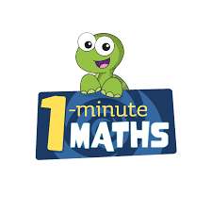

White Rose Maths have created an app called 1-Minute Maths. The app aims to help children build
greater number confidence and fluency through targeted practice in engaging, one-minute
chunks. Your child can choose any topic they want to try. They then answer a unique series of questions
(a different set of questions is generated each time). If they’re finding a question tricky, a ‘hint’
button will give a helpful clue by showing the question in a different way for example. When the

one minute is up, you will see a feedback screen detailing your child’s score. You can use this to move your child’s learning forward. The 1 Minute Maths app requires no login or internet access. It is free to download and available at:

