

Mathematics Home Learning

In Reception, children explore repeating patterns through play, art and building. They learn that a pattern repeats when the same unit happens again and again. Children might use cubes, beads, blocks, colours, shapes or actions to make patterns, including circular patterns around bracelets, plates or crowns.
Key vocabulary: pattern, repeat, repeating unit, same again, next, around, continue.
Key question:
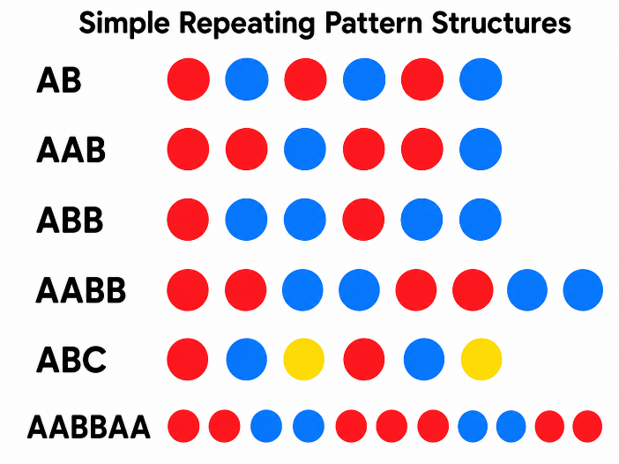

“What comes next in the pattern? How do you know?”

Home Learning Video
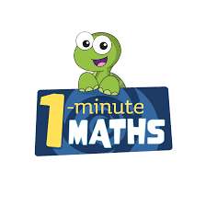

White Rose Maths have created an app called 1-Minute Maths. The app aims to help children build
greater number confidence and fluency through targeted practice in engaging, one-minute
chunks. Your child can choose any topic they want to try. They then answer a unique series of questions
(a different set of questions is generated each time). If they’re finding a question tricky, a ‘hint’
button will give a helpful clue by showing the question in a different way for example. When the

one minute is up, you will see a feedback screen detailing your child’s score. You can use this to move your child’s learning forward. The 1 Minute Maths app requires no login or internet access. It is free to download and available at:

