

Mathematics Home Learning
In Reception, children begin exploring taking away and learning how to work out how many are left. They practise starting with a group of objects and then taking some away, noticing that the total becomes smaller. Children are encouraged to count carefully and understand that taking away means removing objects from a group. They begin to recognise that they can find out how many are left by counting the remaining objects after some have been taken away.
Through practical, hands-on activities, children use objects, counters, cubes, toys, and real-life situations to explore subtraction in meaningful ways. For example, they might start with 8 cubes and take 3 away, then count to find that there are 5 left. Children also learn to look closely at what has changed by comparing the starting number with the new amount. This helps them to work out how many have been taken away. They are encouraged to use mathematical language such as take away, less, left, how many, first, then, now, fewer, count back, smaller and how many are left? By exploring taking away in practical contexts, children develop confidence in understanding how numbers change when some are removed.
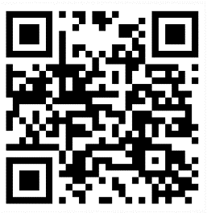
You can support your child at home by encouraging them to notice and talk about taking away in everyday situations. For example, you might say, “You have 6 carrot sticks and you eat 2. How many do you have left?” You could also ask them to build a tower, take away some blocks, and work out how many blocks were removed. Encourage your child to explain their thinking by asking questions such as: How many did you start with? How many did you take away? How many are left now? Did the number get bigger or smaller? How do you know?
Home Learning Video

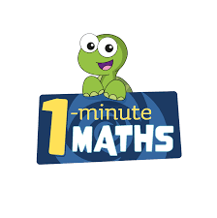

White Rose Maths have created an app called 1-Minute Maths. The app aims to help children build
greater number confidence and fluency through targeted practice in engaging, one-minute
chunks. Your child can choose any topic they want to try. They then answer a unique series of questions
(a different set of questions is generated each time). If they’re finding a question tricky, a ‘hint’
button will give a helpful clue by showing the question in a different way for example. When the

one minute is up, you will see a feedback screen detailing your child’s score. You can use this to move your child’s learning forward. The 1 Minute Maths app requires no login or internet access. It is free to download and available at:

