

Mathematics Home Learning

In Reception, children begin to explore odd and even numbers through practical sharing activities. They learn that some numbers can be shared fairly into two equal groups, while others have one left over. Children use objects such as counters, cubes, toys or snacks to share between two people. For example, they might share 6 cubes between 2 children and notice that both children get 3 each, therefore 6 is an even number. They might share 5 cubes and notice that one cube is left over, therefore 5 is an odd number.
Children are encouraged to use language such as:
odd, even, share, equal, fair, same, different, left over, one each, and two groups.
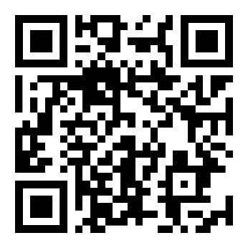
You can help by noticing odd and even numbers in everyday life. For example, you might say:
“Can we share these strawberries fairly between two people?”
“Does everyone have the same amount?”
“Is there one left over?”
“Do you think that this number is an odd or even number? How do you know?”
Home Learning Video

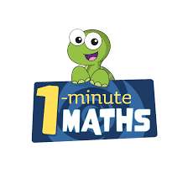

White Rose Maths have created an app called 1-Minute Maths. The app aims to help children build
greater number confidence and fluency through targeted practice in engaging, one-minute
chunks. Your child can choose any topic they want to try. They then answer a unique series of questions
(a different set of questions is generated each time). If they’re finding a question tricky, a ‘hint’
button will give a helpful clue by showing the question in a different way for example. When the

one minute is up, you will see a feedback screen detailing your child’s score. You can use this to move your child’s learning forward. The 1 Minute Maths app requires no login or internet access. It is free to download and available at:

