

Mathematics Home Learning
In Reception, children begin exploring 3D shapes to understand the properties of shapes that are solid and can be held. They learn to recognise and name common 3D shapes such as cubes, cuboids, spheres, cones, cylinders, and pyramids. Through practical, hands-on activities, children use real objects and models to notice what makes each shape special, for example, whether it can roll, slide, or stack, and how many faces, edges, or corners it has. Children are encouraged to use mathematical language such as face, edge, corner, roll, slide, and stack. They learn that some shapes may look different but still share similar properties, and that knowing about 3D shapes helps us to describe and compare the world around us. By exploring 3D shapes in meaningful contexts, children develop confidence in understanding how shapes fit into everyday life.


You can support your child at home by inviting them to practise noticing 3D shapes in everyday situations. For example, you might ask them to find different 3D shapes around the house, such as a tin that is a cylinder or a ball that is a sphere, and describe what they notice about each one. Encourage your child to explain their thinking by asking questions such as: How do you know?”

Home Learning Video
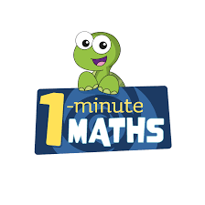

White Rose Maths have created an app called 1-Minute Maths. The app aims to help children build
greater number confidence and fluency through targeted practice in engaging, one-minute
chunks. Your child can choose any topic they want to try. They then answer a unique series of questions
(a different set of questions is generated each time). If they’re finding a question tricky, a ‘hint’
button will give a helpful clue by showing the question in a different way for example. When the

one minute is up, you will see a feedback screen detailing your child’s score. You can use this to move your child’s learning forward. The 1 Minute Maths app requires no login or internet access. It is free to download and available at:

