
G

Phonics at Home: Speed Sounds and Fred Games
In phonics this week, we are playing Fred Games and learning Set 1 sounds. Fred Games familiarise us with Set 1 sounds together with supporting us to blend to read words containing Set 1 sounds. Please scan the QR codes below to support your child to recap what we have learnt this week.






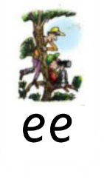
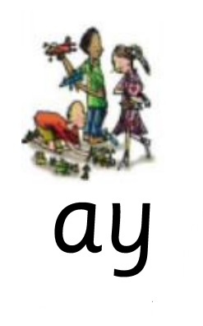
Word Time

