

Mathematics Home Learning
In Reception, children begin exploring length and height to understand how objects can be measured and compared. They learn to notice whether something is longer, shorter, taller, or shorter than something else. Through practical, hands-on activities, children compare objects directly — for example, placing two pencils side by side to see which is longer — and begin to order items from shortest to longest or tallest to shortest. Children are encouraged to use mathematical language such as long, short, tall, longer, shorter, tallest, shortest, and same/equal length/height. They learn that height usually describes how tall something is, while length often describes how long something is from end to end. By exploring these ideas in meaningful contexts, children develop an early understanding of measurement and comparison.

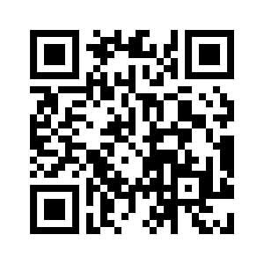
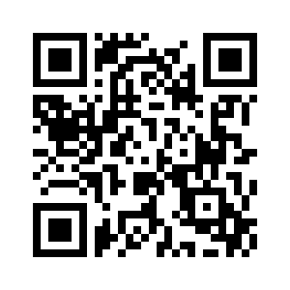
You can help at home by inviting your child to compare everyday objects. For example, you might ask them to find two spoons and decide which is longer, or order towers of blocks from tallest to shortest. Encourage them to explain their thinking by asking questions such as: “Which one is longer? How do you know?” and “Can you find something shorter than this?”

Home Learning Videos

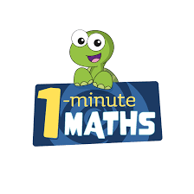

White Rose Maths have created an app called 1-Minute Maths. The app aims to help children build
greater number confidence and fluency through targeted practice in engaging, one-minute
chunks. Your child can choose any topic they want to try. They then answer a unique series of questions
(a different set of questions is generated each time). If they’re finding a question tricky, a ‘hint’
button will give a helpful clue by showing the question in a different way for example. When the

one minute is up, you will see a feedback screen detailing your child’s score. You can use this to move your child’s learning forward. The 1 Minute Maths app requires no login or internet access. It is free to download and available at:

