

Mathematics Home Learning
In Reception, children begin exploring number bonds to ten to understand how numbers can be combined and separated. They learn to notice how two smaller numbers can join together to make ten, and how ten can be split into different pairs. Through practical, hands-on activities, children use objects such as counters, cubes, or fingers to find different ways to make ten, for example, combining six and four, or seven and three. Children are encouraged to use mathematical language such as part, whole, make, add, and altogether. They learn that different pairs of numbers can have the same total, and that knowing these bonds help us to become more fluent in our number work. By exploring number bonds in meaningful contexts, children develop confidence in understanding how numbers fit together.

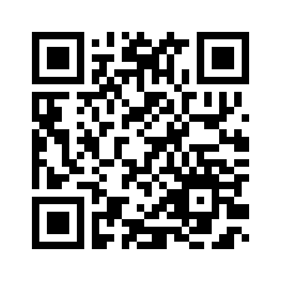
You can support your child at home by inviting them to practise number bonds to ten in everyday situations. For example, you might ask them to show different ways to make ten using toys or pieces of fruit, and say the number sentence (six add four equals/is the same as ten). Encourage your child to explain their thinking by asking questions such as: How do you know?”

Home Learning Video

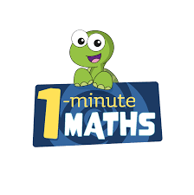

White Rose Maths have created an app called 1-Minute Maths. The app aims to help children build
greater number confidence and fluency through targeted practice in engaging, one-minute
chunks. Your child can choose any topic they want to try. They then answer a unique series of questions
(a different set of questions is generated each time). If they’re finding a question tricky, a ‘hint’
button will give a helpful clue by showing the question in a different way for example. When the

one minute is up, you will see a feedback screen detailing your child’s score. You can use this to move your child’s learning forward. The 1 Minute Maths app requires no login or internet access. It is free to download and available at:

