

Mathematics Home Learning
In Reception, children begin exploring numbers to ten to understand how quantities can be compared and ordered. They learn to notice whether one number is bigger, smaller, more, or less than another number. Through practical, hands-on activities, children compare numbers directly — for example, counting two groups of objects to see which has more — and begin to order numbers from zero to ten or from ten back to zero. Children are encouraged to use mathematical language such as more, less, greater, smaller, biggest, smallest, and the same number. They learn that a bigger number means a larger amount, while a smaller number means fewer objects in a group. By exploring these ideas in meaningful contexts, children develop an early understanding of number value and comparison.
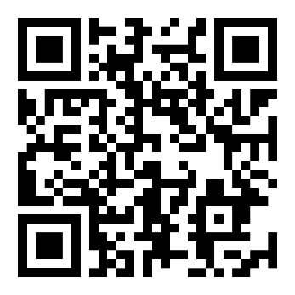
You can help at home by inviting your child to compare numbers in everyday situations. For example, you might ask them to count two groups of toys and decide which has more, or put number cards in order from zero to ten. Encourage them to explain their thinking by asking questions such as: “Which number is bigger? How do you know?”

Home Learning Video

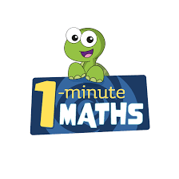

White Rose Maths have created an app called 1-Minute Maths. The app aims to help children build
greater number confidence and fluency through targeted practice in engaging, one-minute
chunks. Your child can choose any topic they want to try. They then answer a unique series of questions
(a different set of questions is generated each time). If they’re finding a question tricky, a ‘hint’
button will give a helpful clue by showing the question in a different way for example. When the

one minute is up, you will see a feedback screen detailing your child’s score. You can use this to move your child’s learning forward. The 1 Minute Maths app requires no login or internet access. It is free to download and available at:

