

Mathematics Home Learning
In Reception, children learn to find numbers within groups, focusing on 6, 7 and 8. They practise counting objects carefully, saying one number for each item and understanding that the last number counted is how many there are altogether. Children explore different arrangements of objects and learn that moving them does not change the total. They use mathematical language such as count, how many, altogether, group, more, less, and the same.

You can help at home by asking your child to find 6, 7 or 8 objects (such as toys, spoons or crayons), encouraging them to touch each object as they count so they do not miss any out. Ask them to explain how they know the total, for example, “I counted seven because I said seven last,” which helps to build confidence and secure understanding of early number skills.

Home Learning Video

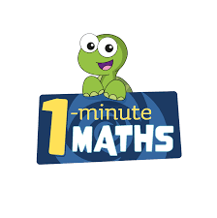

White Rose Maths have created an app called 1-Minute Maths. The app aims to help children build
greater number confidence and fluency through targeted practice in engaging, one-minute
chunks. Your child can choose any topic they want to try. They then answer a unique series of questions
(a different set of questions is generated each time). If they’re finding a question tricky, a ‘hint’
button will give a helpful clue by showing the question in a different way for example. When the

one minute is up, you will see a feedback screen detailing your child’s score. You can use this to move your child’s learning forward. The 1 Minute Maths app requires no login or internet access. It is free to download and available at:

