

Mathematics Home Learning
In Reception, children begin learning about making doubles to explore number patterns and relationships. They practise combining two equal groups of objects, noticing how doubling means "the same again." Through hands-on activities, children discover that doubling helps numbers grow in a predictable way — for example, two and two make four, or three and three make six. They are encouraged to use mathematical language such as double, same, equal, total, and altogether. This helps them recognise patterns in numbers and understand how quantities can be combined and compared.

You can help at home by asking your child to find and make doubles with everyday objects such as spoons or toy cars. Encourage them to set out a group of items, then make another group that is the same. Ask questions like, “Can you make the same number again?” and “How many do you have altogether?” Talking through their thinking — for example, “Four and four make eight, so double four is eight” — supports confidence and strengthens their early number sense.
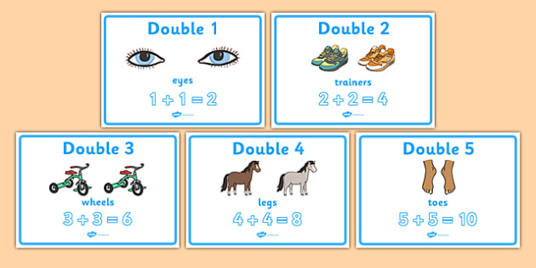

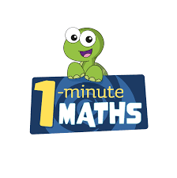

White Rose Maths have created an app called 1-Minute Maths. The app aims to help children build
greater number confidence and fluency through targeted practice in engaging, one-minute
chunks. Your child can choose any topic they want to try. They then answer a unique series of questions
(a different set of questions is generated each time). If they’re finding a question tricky, a ‘hint’
button will give a helpful clue by showing the question in a different way for example. When the

one minute is up, you will see a feedback screen detailing your child’s score. You can use this to move your child’s learning forward. The 1 Minute Maths app requires no login or internet access. It is free to download and available at:

