

Mathematics Home Learning
In Reception, children begin learning about making pairs to explore odd and even numbers. They practise grouping objects into twos, noticing whether each item has a partner or if one is left over. Through hands-on activities, children discover that when all objects can be paired with none left, the number is even, and when one object does not have a partner, the number is odd. They are encouraged to arrange objects in lines or small groups and to use mathematical language such as pair, even, odd, left over, group, share, and equal. This helps them see patterns in numbers and builds a deeper understanding of how quantities can be organised.


You can help at home by asking your child to make pairs with everyday objects such as socks or building blocks. Encourage them to line the items up and match them two at a time, checking carefully to see if any are left without a partner. Ask questions like, “Is there one left over or are they all in pairs?” and “So is that number odd or even?” Talking through their thinking — for example, “Eight is even because they all have a partner” — supports confidence and strengthens their early number knowledge.

Home Learning Video

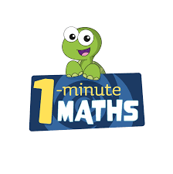

White Rose Maths have created an app called 1-Minute Maths. The app aims to help children build
greater number confidence and fluency through targeted practice in engaging, one-minute
chunks. Your child can choose any topic they want to try. They then answer a unique series of questions
(a different set of questions is generated each time). If they’re finding a question tricky, a ‘hint’
button will give a helpful clue by showing the question in a different way for example. When the

one minute is up, you will see a feedback screen detailing your child’s score. You can use this to move your child’s learning forward. The 1 Minute Maths app requires no login or internet access. It is free to download and available at:

