
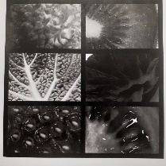

Year 6
Art and Design: Photo Opportunity
Knowledge

I know macro photography focuses on extreme close-up detail to turn ordinary objects into abstract images.
Vocabulary
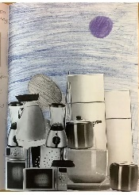
Composition:
The way different elements of an image are intentionally arranged to create a balanced and effective picture.
Photomontage:
A picture made by combining different photographs together to create one new image.
Monochrome:
An artwork image made using only one colour and its lighter and darker shades.
Saturation:
How strong or intense a colour appears in an image (low saturation appears dull, high saturation appears bright).
Scale:
The relative size of one object compared to another,
Proportion:
The relationship between the sizes of different parts of something; correct proportion makes drawings look realistic.

I know that design choices such as layout, colour, and imagery communicate meaning in a digital composition.
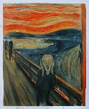
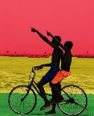
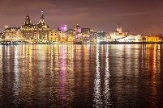
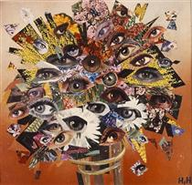
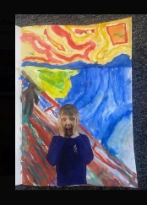

‘The Scream’ (1893) by Norwegian painter Edvard Munch.
‘The Thought of You Reminds Me of Home’ (2019) by Ghanaian digital collage artist Derrick O. Boateng.
‘Liverpool Waterfront’ (2010) by British landscape photographer Graham Holland.
‘Strauss’ (1929) by German Dada artist Hannah Höch.
I know that using a grid helps to accurately observe and draw to correct proportions for a photorealistic portrait.
I know that composition (arrangement of visual elements) is essential for an effective photomontage.
I know that photography can be used to accurately recreate the composition of a famous artwork.

Inspirational Works

