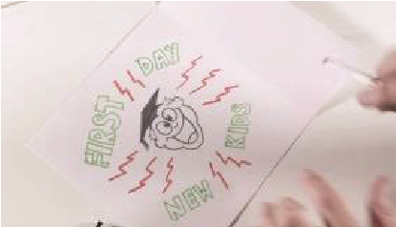
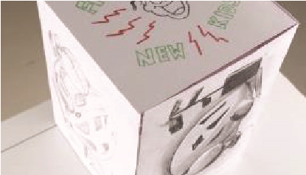
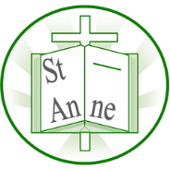
Vocabulary
Year 6
Art and Design: Still Life
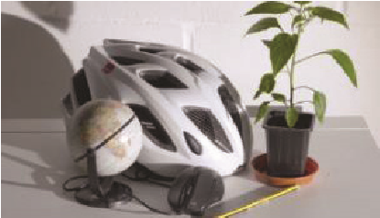
Techniques

Realism:
The realist movement began in France in the 1850s, after the 1848 Revolution. The main goal of realism was to depict the positives and negatives of everyday life.
Highlights/Shadows:
Highlights are created by using tints of colours to reflect the areas where light hits the object. Shadows are created by using shades of colours to show the areas where light is not hitting an object.
Negative Image:
A negative image is created by first darkening an entire canvas before using a complimentary colour to create an image. Underpainting:
Underpainting is an initial layer of paint applied to a canvas, which serves as a base for subsequent layers of paint. Underpaintings are often monochromatic and help to define color values for later painting.
I know how to arrange and sketch a selection of objects with a focus on composition.
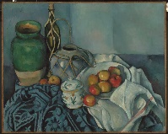
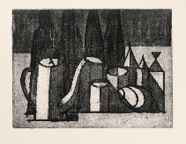
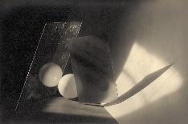
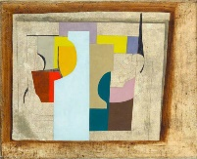
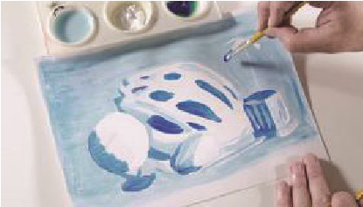
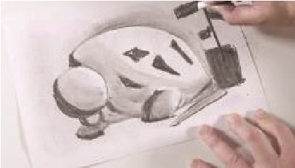
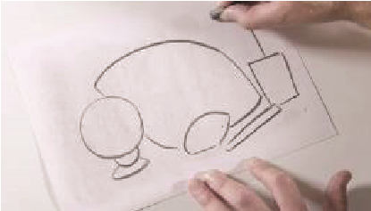
I know how to create a negative image by using an eraser to define lines and shapes and mark out areas of light and shadow.
I know how to mix and apply paint to add dynamic colour with a range of tints and shades.
I know how to showcase my drawings in 3D form by creating a box with a different piece on each face together with a visual representation of the memories and emotions they evoke.
I know how to recreate a still life drawing using the medium of charcoal.
‘Still Life with Apples’ (1894) by French artist Paul Cezanne.
‘Still Life 15’ (1957) by Brazilian artist Ibere Bassanti Camargo.
‘Composition – glass and ball’ (1923) by Czech artist Jaromír Funke.
‘1946 (still life)’ by British artist Ben Nicholson.

Inspirational Works

