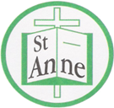

Year 6 Art and Design
Curriculum Booklet
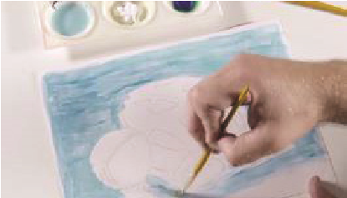
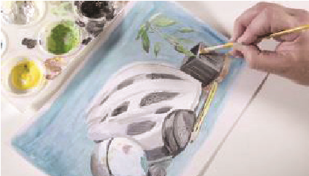
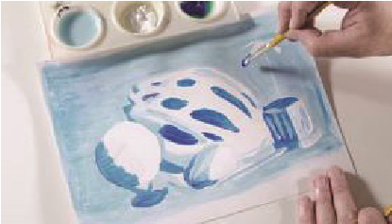

National Curriculum for Art and Design: Key Stage 2

The national curriculum for art and design aims to ensure that all pupils:
- produce creative work, exploring their ideas and recording their experiences
- become proficient in drawing, painting, sculpture and other art, craft and design techniques
- evaluate and analyse creative works using the language of art, craft and design
- know about great artists, craft makers and designers, and understand the historical and cultural development of their art forms.

Pupils should be taught to develop their techniques, including their control and their use of materials, with creativity, experimentation and an increasing awareness of different kinds of art, craft and design.
Pupils should be taught:
- to create sketch books to record their observations and use them to review and revisit ideas
- to improve their mastery of art and design techniques, including drawing, painting and sculpture with a range of materials [for example, pencil, charcoal, paint, clay]
- about great artists, architects and designers in history.
Year 6: Autumn Term
Drawing: Expressing Ideas
Lesson | Outline | Outcome
What is  Street Art? | Pupils explore how street artists use art to convey messages and provoke thought. | 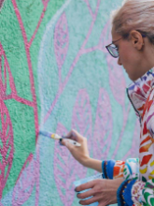
How do Artists  use One Point Perspective? | Pupils understand and apply one point perspective in a street art inspired drawing. | 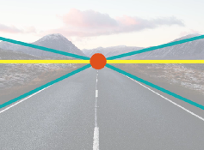  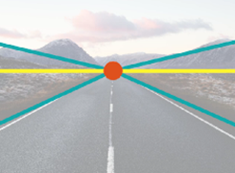
Scaling Up | Pupils use scale and proportion effectively in drawings. | 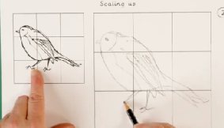
Planning  Street Art | Pupils design a street-art-inspired final piece; combining skills learned. | 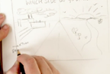
Making a Street-Art-Inspired Piece | Pupils scale up a street-art-spired design that conveys a message using perspective, scale and proportion. | 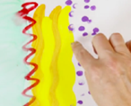  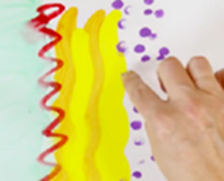

Year 6 Autumn Term:
Ideas to Support Your Child’s Learning at Home
Graffiti
Spray-painted words and images that appear on property without permission. Mural
A painting made directly on a wall or other permanent structure.
Street Art
Artwork that is created in a public space, typically without official permission.
Depth
The feeling in a picture that some things are closer and others are farther away.
Horizon
The horizontal line that separates the sky from the ground, creating perspective.
Realism
A way of making art that looks as close to real life as possible.
Vanishing Point
A spot on the horizon where things seem to disappear.

Talk about our key vocabulary at home.

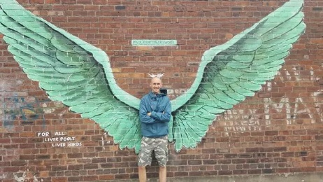

Visit For All Liverpool's Liver Birds (Wings) by Paul Curtis; iconic colourful street art wings on Jamaica Street in the Baltic Triangle area. A perfect place for photos and a good starting point for exploring surrounding murals and graffiti art in the Baltic Triangle.

Year 6 Autumn Term:
Ideas to Support Your Child’s Learning at Home
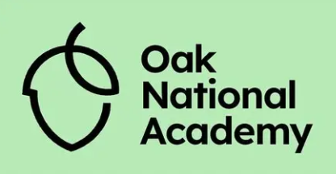
Visit Oak National Academy’s Street Art lesson for Year 6.
Watch the video and discuss how street artists use colour, symbols and words to share ideas.

Work with your child to freely reate a piece of artwork, applying their newly developed skills.

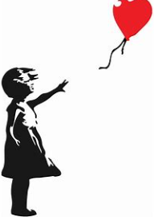
Support your child to explore graffiti and street art as a form of creative expression, inspired by artists like Banksy and Jean-Michel Basquiat.
What you’ll need:
- Large sheet of paper or cardboard
- Pencils, felt tips, markers or paint

Year 6: Spring Term
Still Life
Lesson | Outline | Outcome
Learning about the Work of Edward Hopper | Pupils analyse works of art such as Edward Hopper's 'Nighthawks', answering questions on fundamental principles in art, including; scene, technique, form and shape, colour and light. | 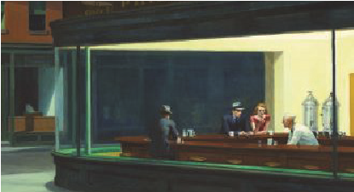
Still Life Composition | Pupils arrange and sketch their own selection of objects with a focus on composition. | 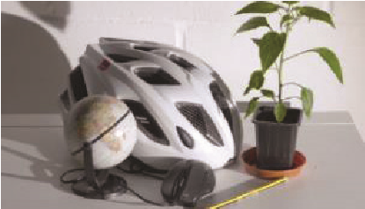
Charcoal Still Life | Pupils recreate a still life drawing using the medium of charcoal. | 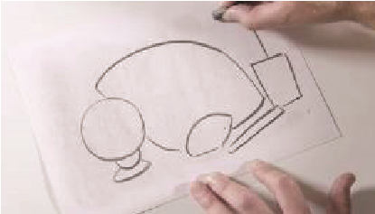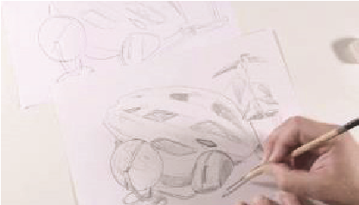
Negative Medium  Still Life | Pupils create a negative image by using an eraser to define lines and shapes and mark out areas of light and shadow. | 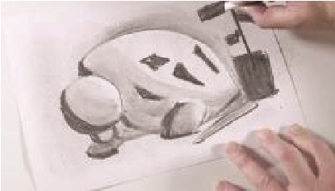
Still Life  in Colour | Pupils mix and apply paint to add dynamic colour to their still life with a range of tints and hues.
Assembling the Memory Box | Pupils showcase their work in 3D form by creating a box with a different still life piece on each face together with a visual representation of the memories and emotions they evoke. | 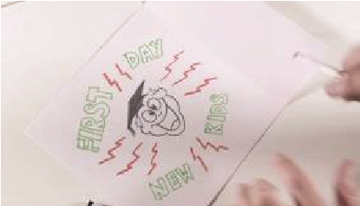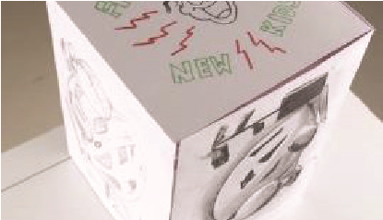

Year 6 Spring Term
Ideas to Support Your Child’s Learning at Home
Talk about our key vocabulary at home.
Realism:
The realist movement began in France in the 1850s, after the 1848 Revolution. The main goal of realism was to depict the positives and negatives of everyday life.
Highlights/Shadows:
Highlights are created by using tints of colours to reflect the areas where light hits the object. Shadows are created by using shades of colours to show the areas where light is not hitting an object.
Negative Image:
A negative image is created by first darkening an entire canvas before using a complimentary colour to create an image. Underpainting:
Underpainting is an initial layer of paint applied to a canvas, which serves as a base for subsequent layers of paint. Underpaintings are often monochromatic and help to define color values for later painting.

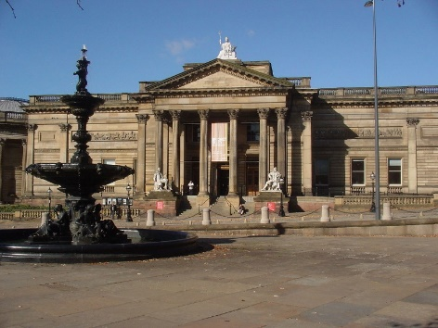

Visit the Walker Art Gallery to view the collection of still life artworks including ‘A mixed bunch’ by Teresa Copnall.

Year 6 Spring Term
Ideas to Support Your Child’s Learning at Home
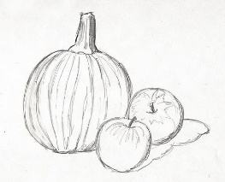
Support your child to create a still life work of art. Follow the link below for a step-by-step guide to a still life art project:
https://www.samanthasbell.com/drawing-a-still-life/

Work with your child to freely create a piece of artwork, applying their newly developed skills.

Support your child to create a 3D sculpture before reflecting their creation in a 2D drawing. Follow the link below for inspiration:
https://naea.digication.com/erinevans/Lesson_1/published
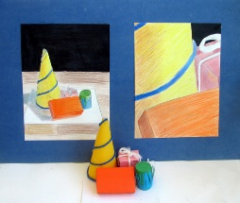

Year 6: Summer Term
Photo Opportunity
Lesson | Outline | Outcome
Photomontage | Pupils create a cityscape photomontage advertising poster inspired by Hannah Hoch, Chris Plowman and Graham Holland. | 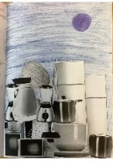
Macro Photography | Pupils understand and apply one point perspective in a street art inspired drawing. | 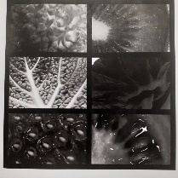
Digital Art | Pupils make design decisions to compose and edit an interesting photographic composition for a music album cover. | 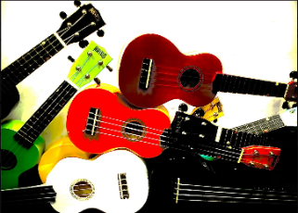
Recreating Paintings | Pupils use photography skills to make design choices to accurately and creatively recreate a famous painting through photography. | 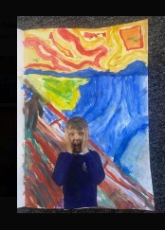
Self Portraits | After exploring self-portraits over time, children use photography to create a contemporary self-portrait. | 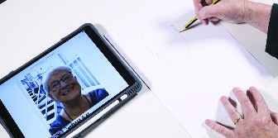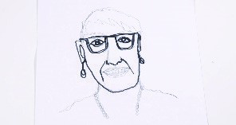
Photorealistic Self-Portraits | Pupils explore the work of photorealistic artists and recreate photographic portraits using a grid drawing technique. | 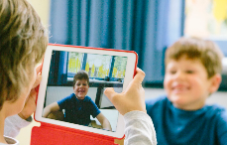

Year 6 Summer Term
Ideas to Support Your Child’s Learning at Home
Composition:
The way different elements of an image are intentionally arranged to create a balanced and effective picture.
Photomontage:
A picture made by combining different photographs together to create one new image.
Monochrome:
An artwork image made using only one colour and its lighter and darker shades.
Saturation:
How strong or intense a colour appears in an image (low saturation appears dull, high saturation appears bright).
Scale:
The relative size of one object compared to another,
Proportion:
The relationship between the sizes of different parts of something; correct proportion makes drawings look realistic.

Talk about our key vocabulary at home.

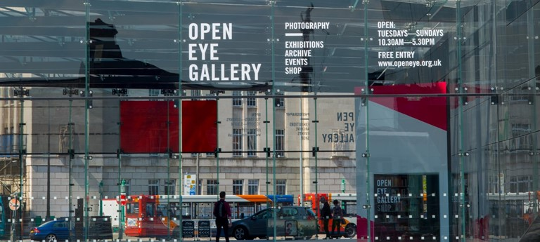

Visit the Open Eye Gallery; a gallery dedicated to photography and related media.

Year 6 Summer Term
Ideas to Support Your Child’s Learning at Home

Support your child to experiment with the art of photography. Follow the link below for a range of photography projects:
https://expertphotography.com/7-fun-photography-projects-children/

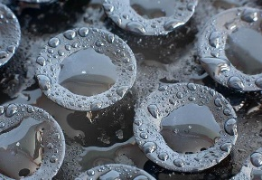

Work with your child to freely create a piece of artwork, applying their newly developed skills.

Support your child to undertake a digital media and art project. Follow the link below for inspiration:
https://www.tts-group.co.uk/blog/2017/07/25/art-illustration-and-photography.html
