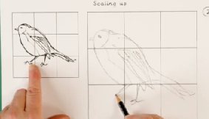
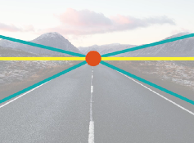
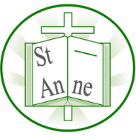
Year 6
Art and Design: Drawing – Expressing Ideas
Knowledge
Scaling up means enlarging a drawing by keeping the shapes in proportion, so that the bigger version looks accurate and balanced.
One point perspective is a when all of the lines in a drawing go back to one vanishing point. Artists use one point perspective to make a picture look realistic or 3D.
Vocabulary
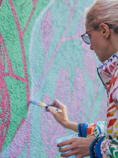

Graffiti
Spray-painted words and images that appear on property without permission. Mural
A painting made directly on a wall or other permanent structure.
Street Art
Artwork that is created in a public space, typically without official permission.
Depth
The feeling in a picture that some things are closer and others are farther away.
Horizon
The horizontal line that separates the sky from the ground, creating perspective.
Realism
A way of making art that looks as close to real life as possible.
Vanishing Point
A spot on the horizon where things seem to disappear.

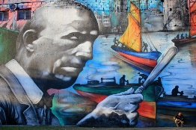
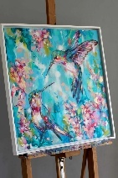
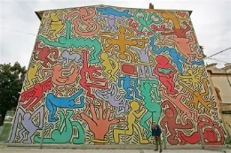
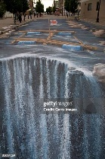
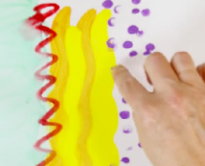
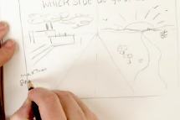
‘El Regreso de Quinquela’ (2013) by Argentinian Muralist Alfredo Segatori.
‘Sakura Dawn’ (2020) by British Wildlife artist Sian Storey.
‘Turning Riverstreet into a River’ (2007) by German Street artist Edgar Müller.
‘Tuttomondo’ (1989) by American Street artist Keith Haring.
When making a street-inspired piece, we use skills like perspective, scale, and proportion to create an eye-catching artwork that shares a message or idea with others.
Street art is a form of public art where artists use images, symbols, and messages in everyday spaces to provoke thought, communicate ideas, and engage with the wider community.
Planning street art means using your ideas and skills such as perspective, scale, and proportion to design a final piece that follows a brief.

Inspirational Works

