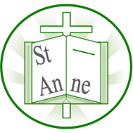
Vocabulary
Year 5
Art and Design: Every Picture Tells A Story
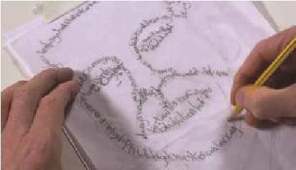
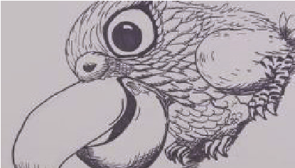
Techniques
I know how to develop an idea through sketching and sourcing pictures, photos and illustrations, before producing a final drawing.

Source Material:
Artists find inspiration in the world around them through sourcing materials such as photographs and illustrations.
Continuous Line Method:
A continuous line drawing is one in which a single, unbroken line is used to develop an image.
Street Art:
Artwork that is created in a public space, typically without official permission.
Graffiti:
Writing or drawings scribbled, scratched, or sprayed, without official permission, on a wall or other surface in a public place.
Political Art:
Political art is created to inspire people to think about a real-world issue.
Rorschach Image:
Images created by dropping ink on paper and folding the paper over to create a mirror image of the inkblot. The abstract images created can be interpreted in different ways.
I know how to draw a portrait using the continuous line method. I know how to add meaningful text to my drawing, varying the size and style of writing to suit the details of my picture.
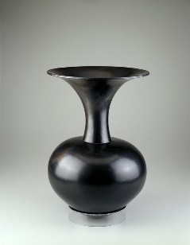
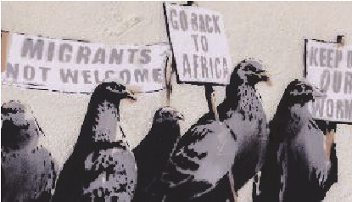
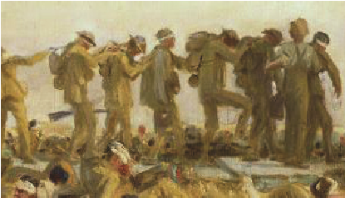
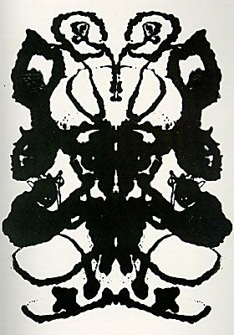
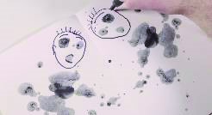
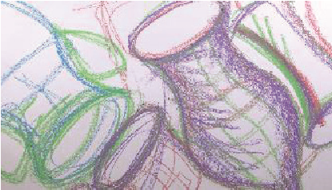
I know how to work in the abstract style of Magdalene Odundo, using coloured chalk and large movements to create different lines and tones.
I know how to create a symmetrical abstract image in the style of the Rorschach method, as inspired by American artist Andy Warhol ‘s ‘Rorschach’ (1984).
‘Reduced Black Piece’ (1990) by Kenyan artist Magdalene Odundo.
I know how to analyse and re-create a political piece of artwork such as ‘Gassed’ (1919) by Italian artist John Singer Sargent.
I know how to explore the political messages within art such as the messages within the works of British artist Banksy.

