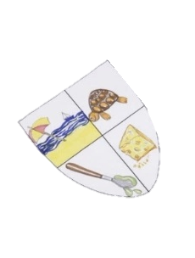
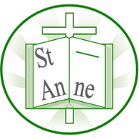
Year 5
Art and Design: Design for a Purpose
A coat of arms uses symbols, colours and imagery to communicate identity. personality, and personal values.
Knowledge
Vocabulary
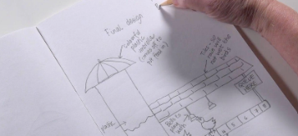

Design:
The design process involves developing a design proposal related to the product specification within a design brief.
Concept
The main idea behind a design or product — what it is meant to be or do.
Prototype:
A prototype is an early model of a product built to test an idea.
Functionality:
The functionality of a product refers to how well it serves its purpose.
USP:
The unique selling point of a product (or service) is a feature of the product that distinguishes it from other similar products and makes it more appealing.
Slogan
A short, catchy phrase used to advertise or describe a product or idea.
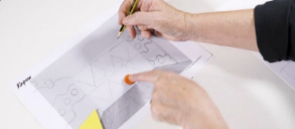
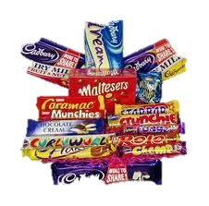
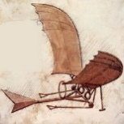
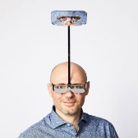
Designers develop inventions by generating several ideas, sketching them out, and refining one design using clear notes and annotations.

Inspirational Works
A design brief explains the purpose and requirements of a project and guides the decisions made when planning a space.
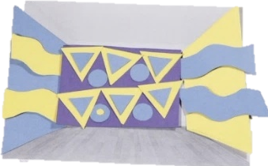
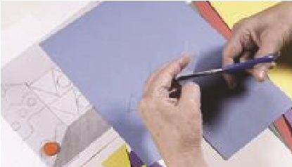
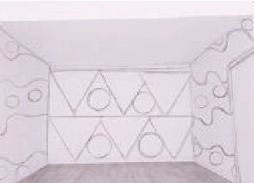
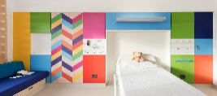
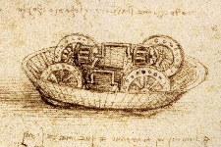
Adverts use persuasive language and strong visual elements to convince an audience of a product’s appeal.
A product name can shape how a product is imagined and designed, influencing its features and purpose.
Using cut-out shapes allows designers to easily test and rearrange different layout ideas before choosing a final design.
British designers Morag Myerscough and Luke Morgan created bold and bright rooms at a children’s hospital in Sheffield (2017).
Italian artist and engineer Leonardo da Vinci (1452-1519) invented objects hundreds of years ago which could not be made then, but, with advances in technology, have since been realised.
‘One Foot Taller’ glasses (2018) by British artist and designer Dominic Wilcox.

