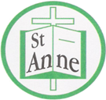

Year 5 Art and Design
Curriculum Booklet

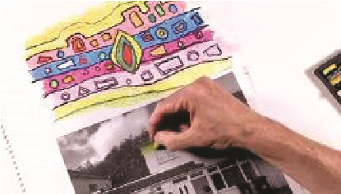
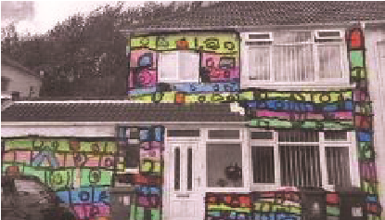

National Curriculum for Art and Design: Key Stage 2

The national curriculum for art and design aims to ensure that all pupils:
- produce creative work, exploring their ideas and recording their experiences
- become proficient in drawing, painting, sculpture and other art, craft and design techniques
- evaluate and analyse creative works using the language of art, craft and design
- know about great artists, craft makers and designers, and understand the historical and cultural development of their art forms.

Pupils should be taught to develop their techniques, including their control and their use of materials, with creativity, experimentation and an increasing awareness of different kinds of art, craft and design.
Pupils should be taught:
- to create sketch books to record their observations and use them to review and revisit ideas
- to improve their mastery of art and design techniques, including drawing, painting and sculpture with a range of materials [for example, pencil, charcoal, paint, clay]
- about great artists, architects and designers in history.
Year 5: Autumn Term
Architecture
Lesson | Outline | Outcome
Drawing:  A Walking Line | Pupils extend a drawing outwards using the continuous line method and adding tonal gradation. | 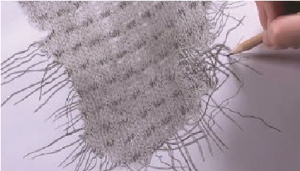
Observational Drawing – Houses | Pupils draw a house from observation; interpreting the details to draw accurately. | 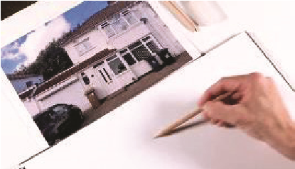
House Monoprints | Pupils apply composition skills to plan a print and use the monoprint technique to create an abstract piece. | 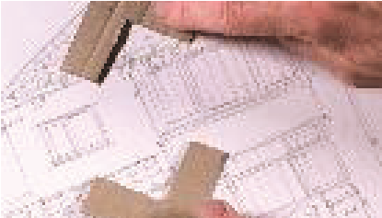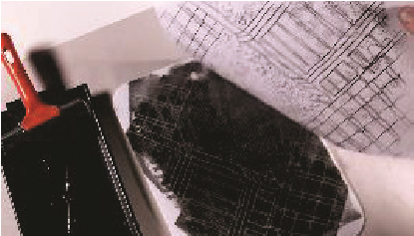
Be an Architect | Pupils design a unique building and justify design choices when evaluating. | 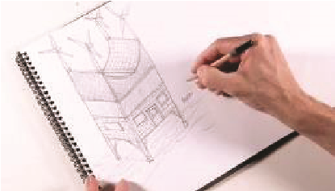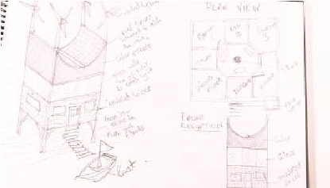
Friedensreich Hundertwasser | Pupils explore the work of Hundertwasser to develop design ideas through sketchbook research.
Monument | Pupils design a monument by reflecting on something important and evaluating how successfully the monument conveys meaning. | 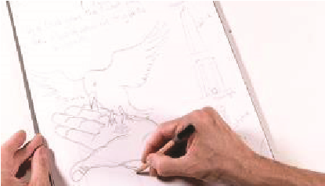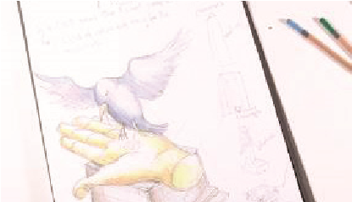

Year 5 Autumn Term:
Ideas to Support Your Child’s Learning at Home
Gradation:
When a colour slowly changes from light to dark.
Architect:
A person who designs buildings.
Architecture:
The design of buildings and other structures.
Design Brief:
Instructions for what you need to design.
Evaluate:
To think about what is good and what can be better.
Crop:
To cut off parts of a picture to make it better.
Viewfinder:
A small frame to help you choose what to draw.
Birds-eye View:
Looking at something from above, like a bird flying.
Front Elevation:
A straight drawing of the front of a building.
Symbolism:
Using pictures or objects to represent ideas.

Talk about our key vocabulary at home.

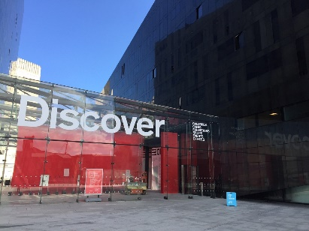

View the architectural exhibitions at RIBA North; a national architecture centre on Liverpool's waterfront.

Year 5 Autumn Term:
Ideas to Support Your Child’s Learning at Home
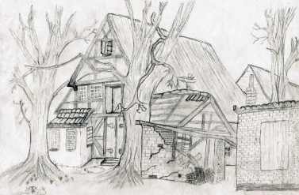
Support your child to complete an observational drawing of a house. Follow the link below for a guide to observational drawing:
https://www.superprof.co.uk/blog/learn-to-draw-real-life/

Work with your child to freely create a piece of artwork, applying their newly developed skills.

Support your child to undertake an architectural project. Follow the link below for resources centred on building a model of a city:
https://www.curbed.com/2020/5/1/21240537/fosters-and-partners-architecture-at-home-projects-kids

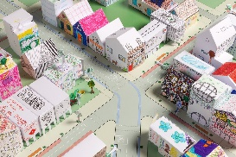

Year 5: Spring Term
Design for a Purpose
Lesson | Outline | Outcome
Design:  Little Inventors | Pupils design a new invention for a set purpose by brainstorming ideas and developing and communicating these through notes and sketches, before selecting one idea and drawing and annotating it in full. | 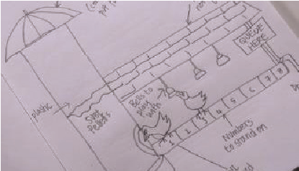
Coat of Arms | After learning about how the coat of arms originated and how they are used today, children create a design of their own. | 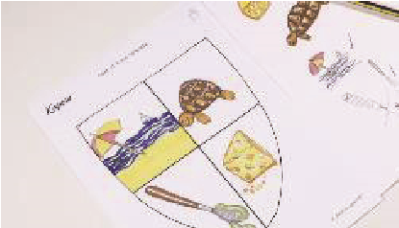
Designing Spaces | Working to a specific brief, children work collaboratively to create a design for an empty room. | 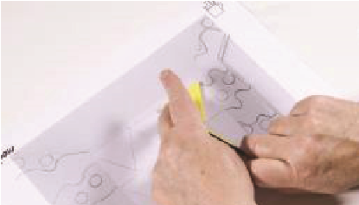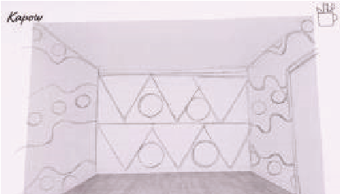
Changing Spaces | After learning about how the coat of arms originated and how they are used today, pupils create a design of their own. | 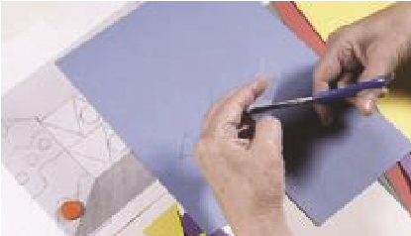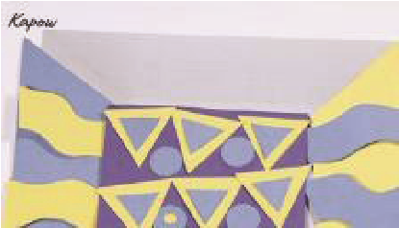
What’s in a Name? | Pupils are given a word as a product name, which they then devise a product idea for.
Adverts | Pupils create and then present a pitch to sell their product.

Year 5 Spring Term
Ideas to Support Your Child’s Learning at Home
Talk about our key vocabulary at home.
Design:
The design process involves developing a design proposal related to the product specification within a design brief.
Prototype:
A prototype is an early model of a product built to test an idea.
Functionality:
The functionality of a product refers to how well it serves its purpose.
USP:
The unique selling point of a product (or service) is a feature of the product that distinguishes it from other similar products and makes it more appealing.

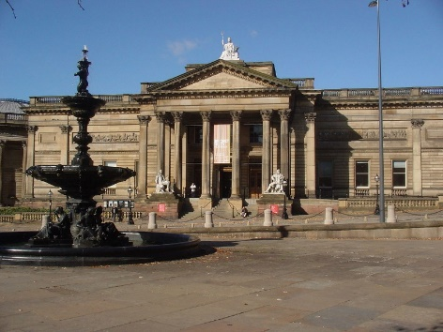

Visit the Walker Art Gallery to view the collection of decorative art, including ceramics, glass, metalwork and furniture by famous designers.

Year 5 Spring Term
Ideas to Support Your Child’s Learning at Home
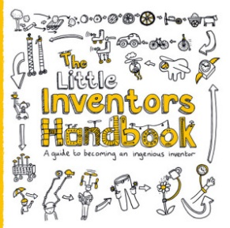
Foster your child’s creativity through enabling them to become an inventor. Follow the link below to find out how your child can develop and showcase their inventions:
https://www.littleinventors.org/about

Work with your child to freely create a piece of artwork, applying their newly developed skills.

Support your child to imagine, create and design a space. Follow the link below for a range of activities centred on designing a space:
https://diy.org/skills/62

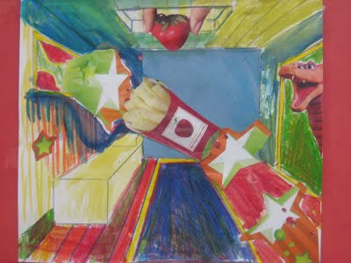

Year 5: Summer Term
Every Picture Tells a Story
Lesson | Outline | Outcome
Learning About How Artists Work | Pupils work imaginatively to develop an idea of their own through sketching and sourcing pictures, photos and illustrations, before producing a final drawing. | 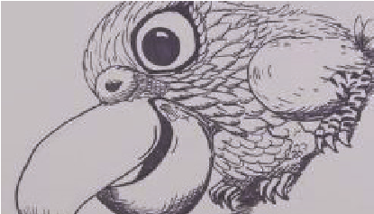
Drawing:  Picture the Poet | Pupils draw a portrait using the continuous line method, before adding text inspired by a poem, varying the size and style of their writing to suit the details of their picture. | 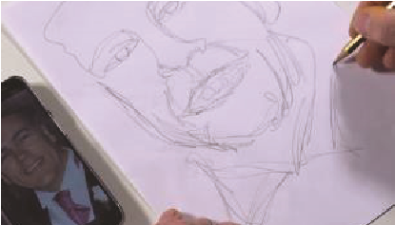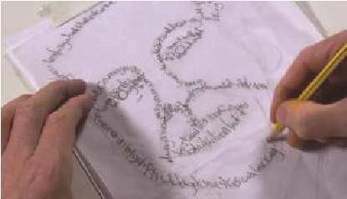
Clacton Pigeon Mural – Banksy | Pupils explore the political messages within art through the work of Banksy (‘Clacton Pigeon Mural’) before altering a work of art to reflect British Values. | 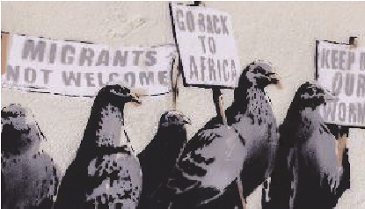
Inspired by Rorschach | Pupils create a symmetrical abstract image in the style of the Rorschach method, as inspired by Andy Warhol (‘Rorschach’). | 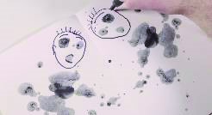
The Front Line – John Singer Sargent | Pupils analyse and re-create a political piece of artwork by John Singer Sargent (‘Gassed’). | 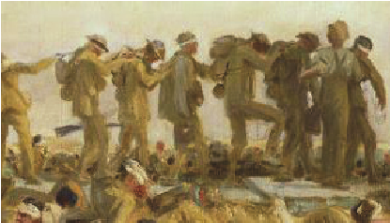
Magdalene Odundo | Pupils work in an unconventional manner, as inspired by Magdalene Odundo, using coloured chalk and their whole bodies to create different lines and tones. | 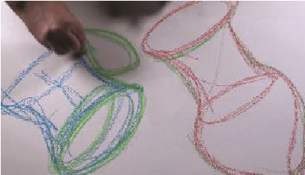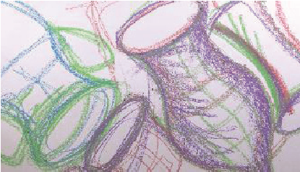

Year 5 Summer Term
Ideas to Support Your Child’s Learning at Home
Talk about our key vocabulary at home.
Source Material:
Artists find inspiration in the world around them through sourcing materials such as photographs and illustrations.
Continuous Line Method:
A continuous line drawing is one in which a single, unbroken line is used to develop an image.
Street Art:
Artwork that is created in a public space, typically without official permission.
Graffiti:
Writing or drawings scribbled, scratched, or sprayed, without official permission, on a wall or other surface in a public place.
Political Art:
Political art is created to inspire people to think about a real-world issue.
Rorschach Image:
Images created by dropping ink on paper and folding the paper over to create a mirror image of the inkblot. The abstract images created can be interpreted in different ways.

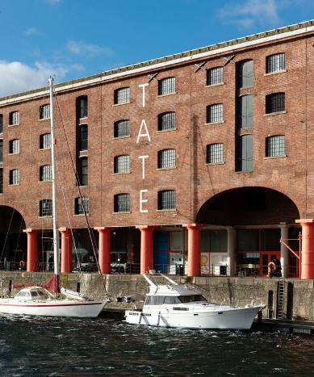

Visit the Tate Liverpool to view a collection of Rorschach paintings by Andy Warhol.

Year 5 Summer Term
Ideas to Support Your Child’s Learning at Home
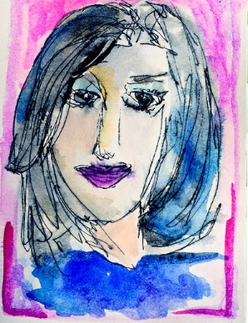
Support your child to draw a portrait using the continuous line method. Follow the link below for inspiration:
https://daisyyellowart.com/vividlife/blind-contour-portrait

Work with your child to freely create a piece of artwork, applying their newly developed skills.

Support your child to create a piece of inkblot artwork and use their creativity to decide what it is. Follow the link below for a step-by-step guide:
https://dssactivities4kids.wordpress.com/2013/04/01/inkblot-art/
