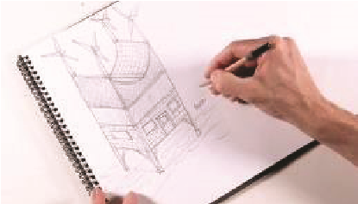
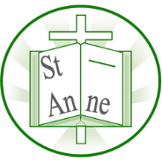
Vocabulary
Year 5
Art and Design: Architecture
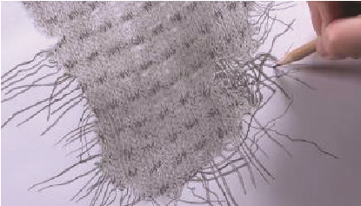
Knowledge

I know that architects design buildings for specific purposes, and their design choices are influenced by function, safety, and aesthetics. original house design.

Gradation:
When a colour slowly changes from light to dark.
Architect:
A person who designs buildings.
Architecture:
The design of buildings and other structures.
Design Brief:
Instructions for what you need to design.
Evaluate:
To think about what is good and what can be better.
Crop:
To cut off parts of a picture to make it better.
Viewfinder:
A small frame to help you choose what to draw.
Birds-eye View:
Looking at something from above, like a bird flying.
Front Elevation:
A straight drawing of the front of a building.
Symbolism:
Using pictures or objects to represent ideas.

I know that a continuous line drawing is made without lifting the pencil from the paper, which helps to improve observation skills and flow in a drawing.
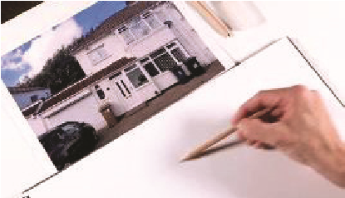
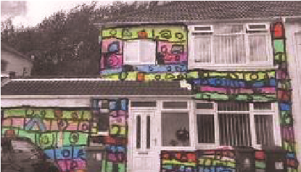
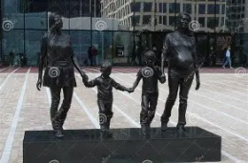
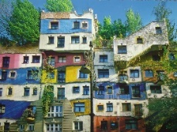
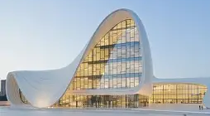
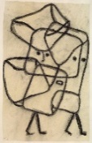
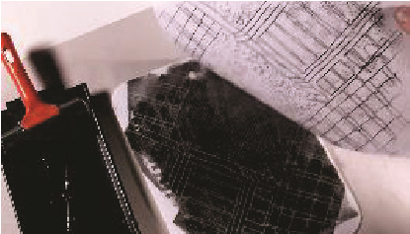
I know that a monument is a structure created to remember or honour a person, event, or idea, and its design elements should convey its intended meaning.

Hundertwasser’s art and architecture often used bright colours, organic forms, and avoided straight lines to reflect harmony with nature.
I know that observational drawing means looking closely at the real object and drawing what you see, not what you think it should look like.
‘A Real Birmingham Family’ (2014) by British artist Gillian Wearing.
‘Hundertwasser House’ (1983) designed by Austrian designer Friedensreich Hundertwasser.
Heydar Aliyev Center (2012) designed by Iraqi architect Zaha Hadid.
‘Burdened Children’ (1930) by Swiss artist Paul Klee.
I know that a monoprint is a one-off print created by transferring ink or paint from a plate to paper, allowing for unique textures and marks.

Inspirational Works

