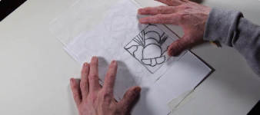
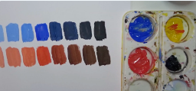
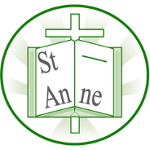
Vocabulary
Year 4
Art and Design: Colour, Light and Pattern
Knowledge
Adding white creates a tint and adding black creates a shade, changing the appearance of a colour.
Abstract
Art that does not show realistic objects; instead it uses shapes, colours, lines, and marks to express ideas.
Figurative
Art that shows recognisable things from the real world, such as people, animals, or objects.
Symmetrical-Reflection:
A figure which does not change upon undergoing a reflection has reflectional symmetry.
Symmetrical Pattern:
A pattern that is identical on both halves when folded. Symmetrical patterns can have multiple lines of symmetry.
Geometric Pattern:
A pattern depicting abstract, nonrepresentational shapes such as lines, circles, triangles and polygons.
Flip Pattern:
A pattern created by tracing pictures into squares of a quadrant.

A reflected shape or pattern appears as a mirror image, and symmetrical designs have matching parts on either side of a line.
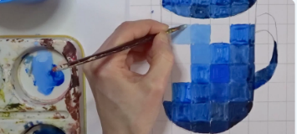
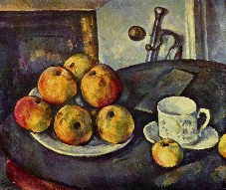
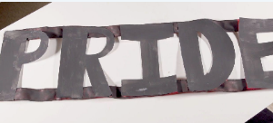
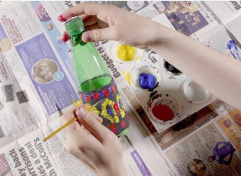
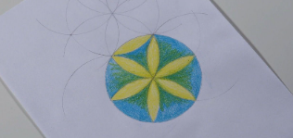
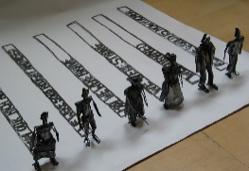
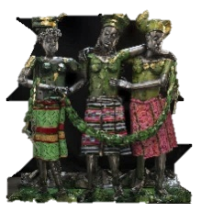
‘Still Life with Apples’ (1895) by French painter Paul Cézanne.
Sokari Douglas Camp creates sculptures using everyday materials and bold lettering, reflecting identify and cultural themes.
As seen in STOMP, musical instruments can be created from reused materials, and repeated patterns are commonly used in West African decoration.
The Flower of Life pattern is created from overlapping circles arranged with equal spacing to form a geometric design.
Light and shadow affect how objects appear, and mixing lighter or darker tones creates a three-dimensional effect.
‘Europe supported by Africa and America’ (2015) and ‘All the World is Now Richer (Memorial Proposal)’ (2012) by Nigerian sculptor Sokari Douglas Camp.

Inspirational Works

