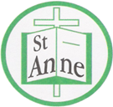

Year 4 Art and Design
Curriculum Booklet

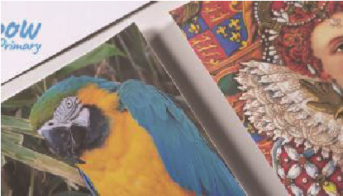
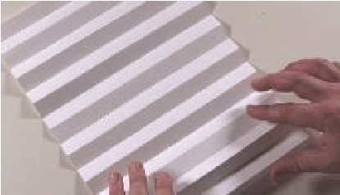
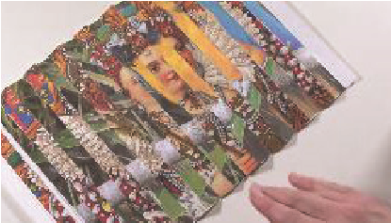

National Curriculum for Art and Design: Key Stage 2

The national curriculum for art and design aims to ensure that all pupils:
- produce creative work, exploring their ideas and recording their experiences
- become proficient in drawing, painting, sculpture and other art, craft and design techniques
- evaluate and analyse creative works using the language of art, craft and design
- know about great artists, craft makers and designers, and understand the historical and cultural development of their art forms.

Pupils should be taught to develop their techniques, including their control and their use of materials, with creativity, experimentation and an increasing awareness of different kinds of art, craft and design.
Pupils should be taught:
- to create sketch books to record their observations and use them to review and revisit ideas
- to improve their mastery of art and design techniques, including drawing, painting and sculpture with a range of materials [for example, pencil, charcoal, paint, clay]
- about great artists, architects and designers in history.
Year 4: Autumn Term-
Effects of Different Perspectives
and Techniques
Lesson | Outline | Outcome
Optical Illusions | Inspired by the ‘lenticular prints’ of Luz Perez Ojeda, children carefully cut two images into strips and by alternating them side by side, in sequential order, and then folding, they create an optical illusion piece of art.
Willow Pattern | Pupils design their own willow pattern style plate, based on a tale of their choice, by first drawing three key characters, then going over the details with undiluted ink, before finally using a water wash to add lighter tones of blue. | 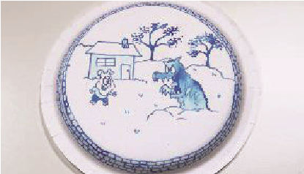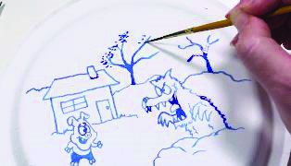
Soap Sculptures | Pupils use a variety of tools to carve a piece of soap into a sculpture in the style of artist and sculptor Barbara Hepworth. | 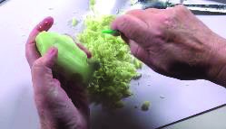
Paul Cézanne | Pupils work in the style of artist Paul Cézanne, mixing colours using short, angular strokes and painting in various directions. | 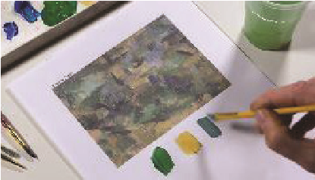
Drawing:  Still Life | Pupils arrange a collection of objects in an interesting way to sketch, drawing the outlines of the objects before adding in light, medium and dark tones to their work; as inspired by the still life artworks of Giorgio Morandi. | 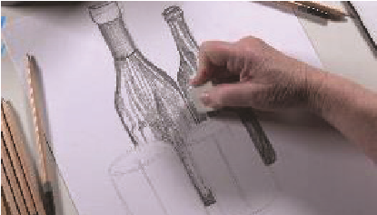
Learning About the Work of a Curator | Pupils curate an exhibition of their own based on, for example, a collection of their most recent artworks. | Key Outcome Questions  What is a curator?  What does a curator do?  What would be useful skills for a curator to have?  How do curators decide where to put things and how to display them?

Year 4 Autumn Term:
Ideas to Support Your Child’s Learning at Home
Optical Illusion:
A picture or design that tricks your eyes into seeing something that is not there.
Distort:
To change the way something looks so it’s stretched or twisted for example.
Perspective:
A way of showing how things look closer or farther away in a picture.
Chinoiserie:
Chinoiserie is a Western style of decorative art that drew upon Chinese motifs and techniques.
Carving:
Cutting into wood, stone, or another material to make shapes or designs.
Figurative:
Art that shows things from the real world, like people, animals, or objects.
Curate:
To curate means to select, organize and look after the objects or works of art in a museum or an art gallery.

Talk about our key vocabulary at home.

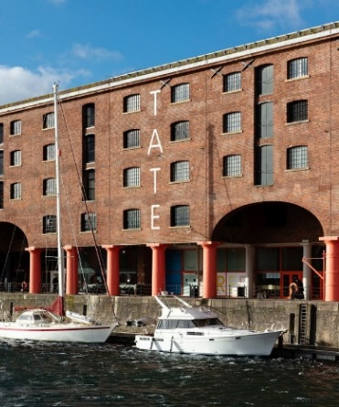

Visit the Tate Liverpool to view a collection of sculptures by Barbara Hepworth including ‘Curved Form’.

Year 4 Autumn Term:
Ideas to Support Your Child’s Learning at Home
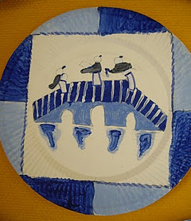
Support your child to illustrate a story using a Willow pattern design. Follow the link below to find out more about the Willow pattern:
http://useyourcolouredpencils.blogspot.com/2010/04/chinese-willow-pattern-plates.html

Work with your child to freely create a piece of artwork, applying their newly developed skills.

Support your child to create a sculpture from soap, before using household objects to adorn it with patterns. Follow the link below for a step-by-step guide:
https://www.tate.org.uk/kids/make/sculpture/soap-carving

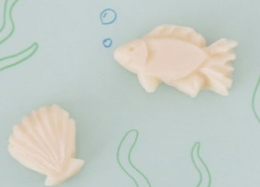

Year 4: Spring Term
Colour, Light and Pattern
Lesson | Outline | Outcome
Tints and Shades | Pupils analyse different painting techniques, comparing paintings by artists according to elements such as texture or colour and practising creating tints and shades when colour mixing. | 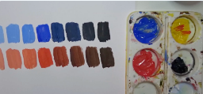
Three Dimensions | Pupils learn more about the effect of light on colour in everyday life and in art. Applying what they learnt previously, they paint a simple object, mixing and using tints and shades to give the appearance of three dimensions. | 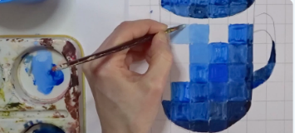
Reflection and Symmetry | Pupils draw an image and then select a small section to trace into one square of a quadrant, they continue flipping and tracing into the next square of the quadrant until the 'flip pattern' is complete. | 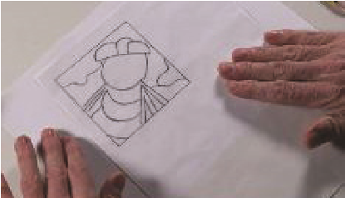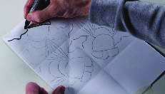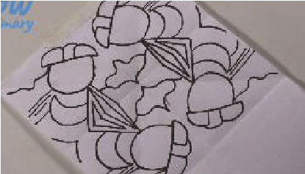
Flower of Life Pattern | Pupils use a compass and following precise instructions, they make an image of overlapping and interconnected circles to recreate the sacred geometric symbol, 'the flower of life'. | 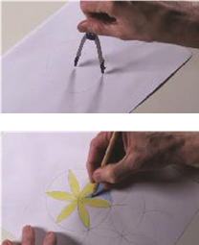  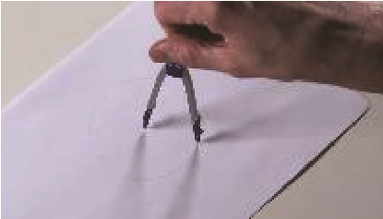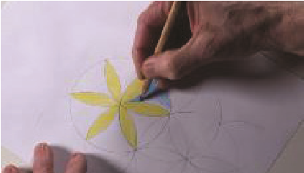
Making Maracas from Recycled Materials | Inspired by STOMP, pupils create maracas using plastic bottles and decorate them with West African patterns. | 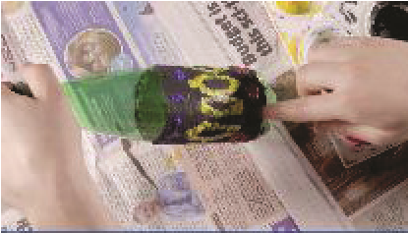
Sokari Douglas Camp | Exploring the work of sculptor, Sokari Douglas Camp, pupils use themselves as an active part of their own sculptures. | 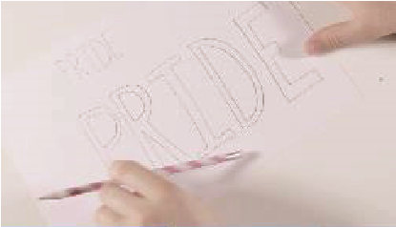  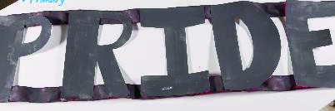

Year 4 Spring Term
Ideas to Support Your Child’s Learning at Home
Abstract
Art that does not show realistic objects; instead it uses shapes, colours, lines, and marks to express ideas.
Figurative
Art that shows recognisable things from the real world, such as people, animals, or objects.
Symmetrical-Reflection:
A figure which does not change upon undergoing a reflection has reflectional symmetry.
Symmetrical Pattern:
A pattern that is identical on both halves when folded. Symmetrical patterns can have multiple lines of symmetry.
Geometric Pattern:
A pattern depicting abstract, nonrepresentational shapes such as lines, circles, triangles and polygons.
Flip Pattern:
A pattern created by tracing pictures into squares of a quadrant.

Talk about our key vocabulary at home.

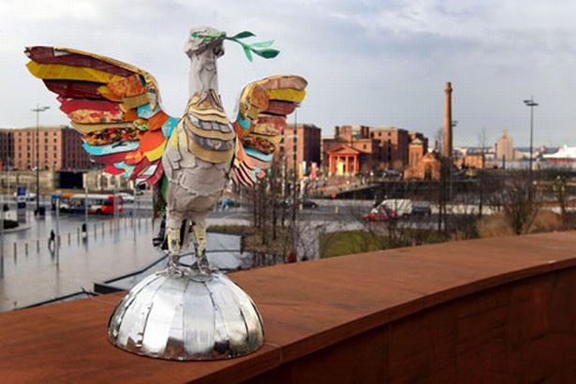

Research and visit local sculptures made from recycled materials such as “Jimmy” – a horse sculpture made with recycled plastic milk bottles on The Liverpool Plinth and “Third Liver Bird” – a giant liver bird sculpture composed of recyclable items.

Year 4 Spring Term
Ideas to Support Your Child’s Learning at Home
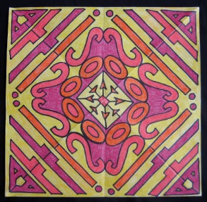
Support your child to apply the concepts of bilateral (reflective) symmetry to transform words into unique designs. Follow the link below for a step-by-step guide:
https://www.teachkidsart.net/kaleidoscope-lettering-design/

Work with your child to freely create a piece of artwork, applying their newly developed skills.

Support your child to create sculptures using recycled materials. Follow the link below for inspiration:
https://www.royalacademy.org.uk/article/family-how-to-make-recycled-sculpture-art-kids-phyllida-barlow-sustainable
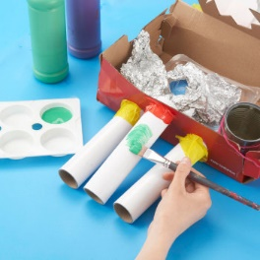

Year 4: Summer Term
Every Picture Tells a Story
Lesson | Outline | Outcome
Texture: Charcoal Mark-Making | Pupils express the meaning of words and phrases in an abstract way, using charcoal to create different textures and effects. | 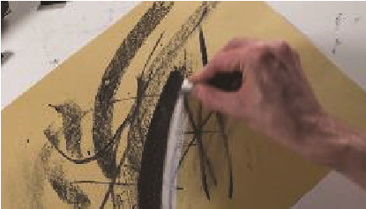
My Parents | Pupils analyse the formal elements in ‘My Parents’ by David Hockney and explore the use of narrative through acting out the scene within the painting. | 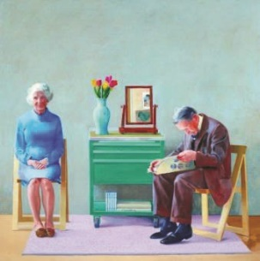
The Dance | Pupils analyse the formal elements and the use of narrative in the work of Paula Rego’s 'The Dance', justifying opinions by referencing specific aspects of the painting. | 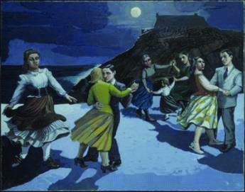
Table for Ladies | Pupils analyse the formal elements and the use of narrative in the realist work of Edward Hopper e.g. ‘Table for Ladies’, using role-play to view the piece from another perspective. | 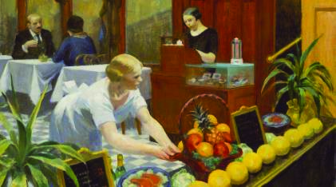
Children’s  Games | Pupils analyse the formal elements and use of narrative in Pieter Brueghel’s painting 'Children's Games' before recreating it as modern art in the form of a photo collage. | 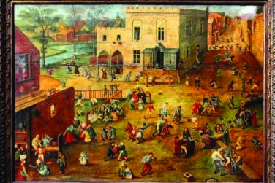
Fiona Rae | Pupils analyse the formal elements and use of narrative in Fiona Rae’s paintings before creating their own abstract piece to represent the same themes. | 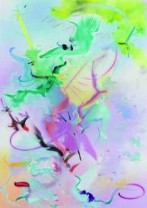

Year 4 Summer Term
Ideas to Support Your Child’s Learning at Home
Talk about our key vocabulary at home.
Narrative Art:
Narrative art is art that tells a story, either as a moment in an ongoing story or as a sequence of events unfolding over time. Realistic/Abstract:
Realist artwork reflects the real world in an almost photographic way.
Abstract artwork does not represent the real world but instead use shapes and colours to achieve different effects.
Variation:
Using a range of different qualities or instances of an art element to create a desired visual effect e.g. a variety of shapes, colors etc.
Formal Elements Vocbulary:
Line – Fine/Bold; Colour - Luminous/Subtle; Form – Curved/Angular; Shape - Geometric/Organic; Texture -
Soft/Grainy; Pattern -
Chaotic/Ordered

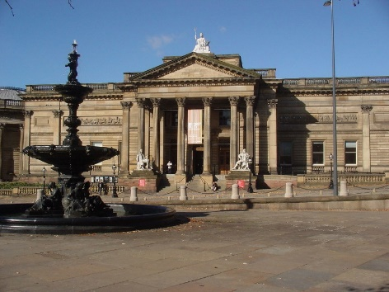

Visit the Walker Art Gallery to view the collection of narrative paintings including ‘One of the Family’ by Frederick George Cotman.

Year 4 Summer Term
Ideas to Support Your Child’s Learning at Home

Support your child to create abstract art with a theme. Follow the link for an abstract art project:
https://lwvogue.com/abstract-art-project-for-kids/
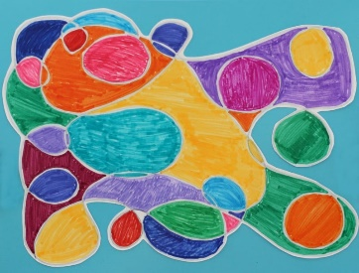

Work with your child to freely create a piece of artwork, applying their newly developed skills.

Support your child to create a piece of narrative artwork; a picture that tells a story. Follow the link below for inspiration:
https://www.artbarblog.com/tell-a-story-with-painting/
