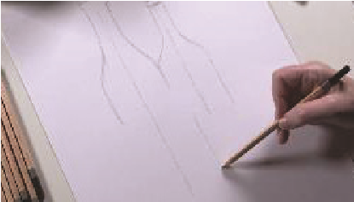
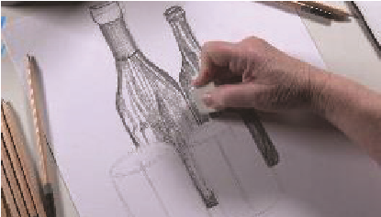
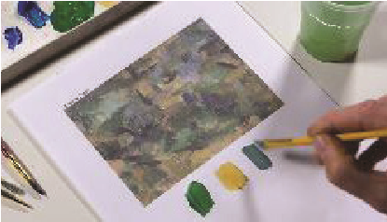
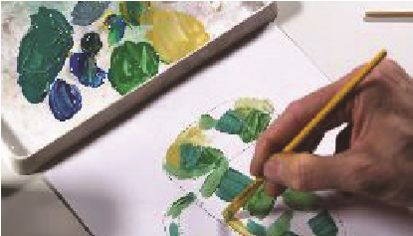
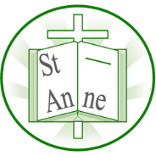
Year 4
Vocabulary
Art and Design: Effects of Different Perspectives and Techniques
Knowledge

Optical Illusion:
A picture or design that tricks your eyes into seeing something that is not there.
Distort:
To change the way something looks so it’s stretched or twisted for example.
Perspective:
A way of showing how things look closer or farther away in a picture.
Chinoiserie:
Chinoiserie is a Western style of decorative art that drew upon Chinese motifs and techniques.
Carving:
Cutting into wood, stone, or another material to make shapes or designs.
Figurative:
Art that shows things from the real world, like people, animals, or objects.
Curate:
To curate means to select, organize and look after the objects or works of art in a museum or an art gallery.
I know that still life drawings use outlines and light, medium, and dark tones to create depth.
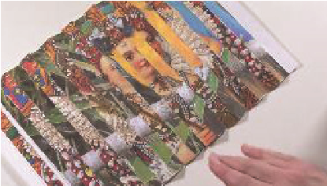
I know that Cézanne used short, angled brush strokes and layers of colour to show shapes and structure.
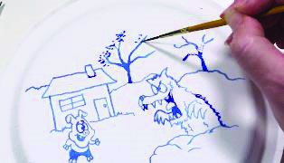
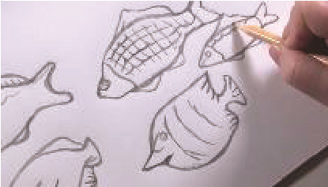
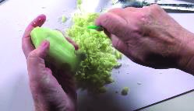
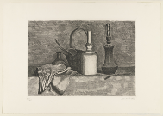
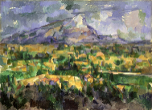
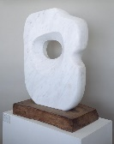
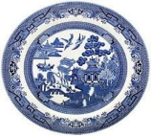
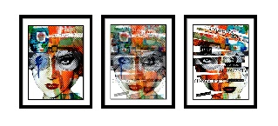
I know that Willow pattern art uses blue ink outlines and light blue wash to tell a story in pictures.
I know that soap can be carved into 3D shapes using sculpting tools, such as in the work of Barbara Hepworth.
I know that cutting and alternating strips of two large images can make an optical illusion, like Luz Perez Ojeda’s lenticular prints.
‘Pierced Form’ (1931) by British artist Barbara Hepworth.
‘Mont Sainte-Victoire’ (1904) by French artist Paul Cézanne.
‘Still Life’ (1950) by Italian artist Giorgio Morandi.

The Willow Pattern (1780) by British artist Thomas Minton.
‘Who am I?’ (2015) by Venezuelan artist Luz Perez Ojeda.

Inspirational Works

