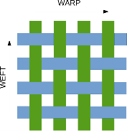
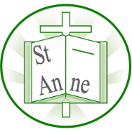
Year 3
Art and Design: Craft

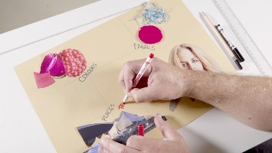

Mood Board:
A mood board is a combination of images, fonts, colors, and textures that define the style of a project.
Intersect:
To pierce or divide by passing through or across.
Tie-dyeing:
To produce patterns in a piece of cloth by tying parts of it to shield from dye.
Natural Material:
Any products that come from plants, animals, or the ground e.g. wood.
Synthetic Material:
Any products made from man-made rather than natural fibers e.g. plastic.
Warp and Weft:
The weaving terms for the directionality of the threads that make up a woven fabric.
Techniques
Vocabulary

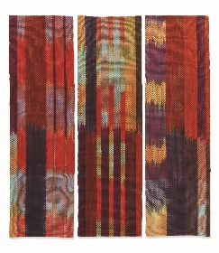
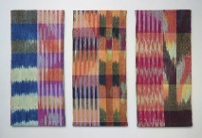
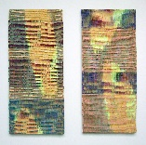
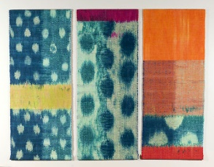
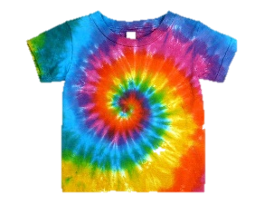
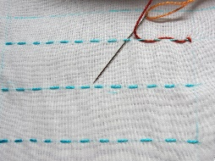
I know how to sew a running stitch to piece fabric together.
I know how to create weave patterns using the warp and weft technique.
I know how to design and construct a mood board by selecting and curating carefully chosen fabrics, pictures, photographs, words and textures together with a personal palette of favourite colours.

I know how to use the process of tie-dyeing to decorate a t-shirt, mixing dyes to create a range of colours and tying in different ways to create unique patterns.
‘Leap Year’ (2012)
‘Serendipity’ (2013)
‘Floating’ (2015)
American artist Ann Roth is known for her experimentation with colour and pattern in her use of the waft and weft technique.
‘Shadow of the Silk Road’ (2011)

Inspirational Works

