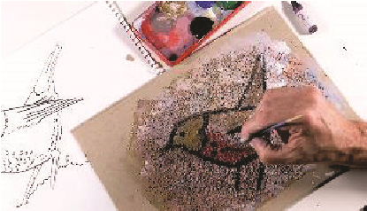
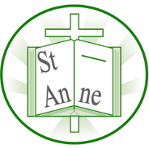
Vocabulary
Year 3
Art and Design: Prehistoric Art
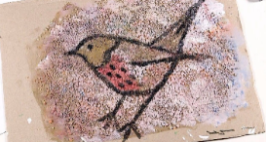
Tertiary Colours:
Tertiary colours are produced by mixing equal amounts of a primary colour with a secondary colour adjacent to it on the colour wheel.
Complementary Colours:
Complementary colours are two colours that are on opposite sides of the colour wheel.
Proportion
The relationship between the sizes of different parts of a drawing or object; how big or small things are compared to each other.
Scaled up
When an object, drawing, or design is enlarged while keeping the same proportions.
Smudging
A technique where lines or tones are softened or blended by rubbing charcoal, pencil, or pastel.
Pigment
The coloured powder used to make paint, chalk, or other colouring materials.
Composition
How the elements of an artwork (shapes, lines, colours, objects) are arranged within the space.
Knowledge
Prehistoric cave artists used simple tools and natural materials to create pictures that told stories about their lives.
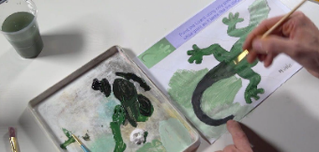
Prehistoric-style painting uses earthy colours and bold shapes to show animals and scenes of early life.
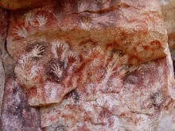
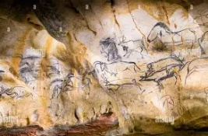
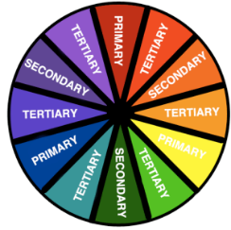
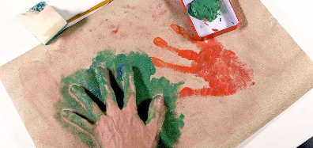
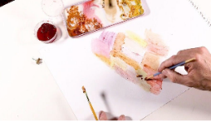
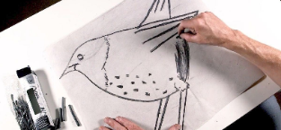
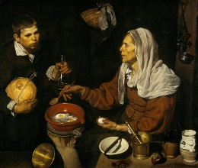
Exploring cave paintings through famous works such as ‘Cueva de las Manos’ (5000BC) and ‘Chauvet Cave’ (c. 30,000–32,000 BC).
Positive handprints show the hand itself, while negative handprints show the outline around the hand.

Charcoal can be used to create different tones by pressing lightly or heavily.
A tint is made by adding white to a colour, and a shade is made by adding black.
Natural pigments – such as ground spices, clay or soil – can be mixed to make different colours.
Exploring blending tones through the work of Spanish artist Diego Velázquez e.g. ‘Old Woman Frying Eggs’ (1618).

Inspirational Works

