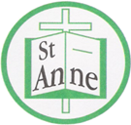

Year 3 Art and Design
Curriculum Booklet

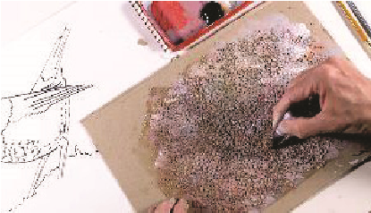
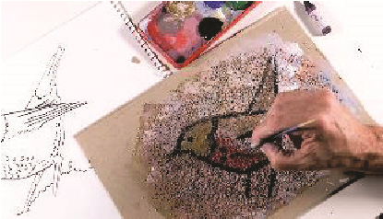

National Curriculum for Art and Design: Key Stage 2

The national curriculum for art and design aims to ensure that all pupils:
- produce creative work, exploring their ideas and recording their experiences
- become proficient in drawing, painting, sculpture and other art, craft and design techniques
- evaluate and analyse creative works using the language of art, craft and design
- know about great artists, craft makers and designers, and understand the historical and cultural development of their art forms.

Pupils should be taught to develop their techniques, including their control and their use of materials, with creativity, experimentation and an increasing awareness of different kinds of art, craft and design.
Pupils should be taught:
- to create sketch books to record their observations and use them to review and revisit ideas
- to improve their mastery of art and design techniques, including drawing, painting and sculpture with a range of materials [for example, pencil, charcoal, paint, clay]
- about great artists, architects and designers in history.
Year 3: Autumn Term- Sketching and Sculpture
Lesson | Outline | Outcome
See Like an Artist | Pupils learn how to use simple shapes to draw objects and develop observation skills. | 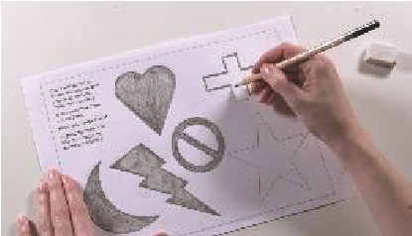
Shading | Pupils learn pencil control to develop tonal shading skills to create even tones. | 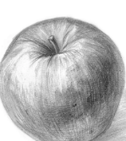
Take a Closer Look | Pupils learn about the importance of observation to notice pattern, texture and tone to add detail to drawings. | 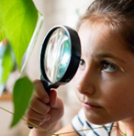
My Toy Story | Pupils draw a favourite soft toy from observation, adding texture by applying mark-making skills. | 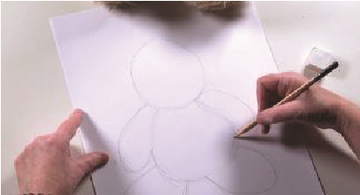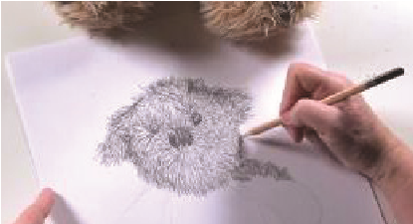
Craft Puppets | Pupils use a variety of materials (polystyrene balls, a selection of paints, card, dowel rods and felt) to make a puppet. | 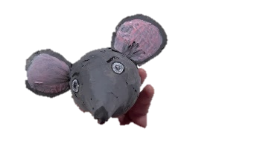  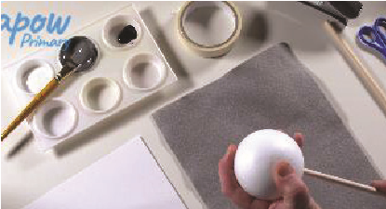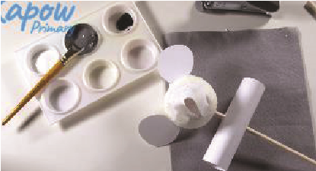

Year 3 Autumn Term:
Ideas to Support Your Child’s Learning at Home
Geometric:
Shapes with straight lines or smooth curves like squares, triangles, and circles.
Organic:
Shapes found in nature, often uneven and curvy, such as a leaf or cloud.
Refine:
To improve something by continuously making minor changes.
Tone:
How light or dark a colour or area appears.
Even Tones:
Shading that appears smooth.
Craft:
To make something with your hands.
3D:
Something that has height, width, and depth.

Talk about our key vocabulary at home.

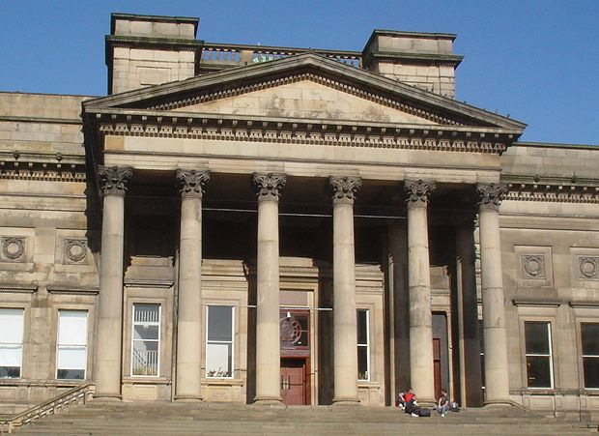

Visit the World Cultures gallery at the World Museum to view puppets such as ‘Durna’; a shadow puppet character with a distinctive design.

Year 3 Autumn Term:
Ideas to Support Your Child’s Learning at Home
Support your child to draw the objects that interest them. Follow the link below for a guide to observational drawing:
https://artfulparent.com/observational-drawing-for-kids/

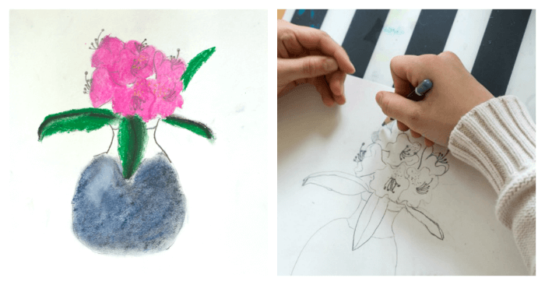

Work with your child to freely create a piece of artwork, applying their newly developed skills.

Support your child to create shadow puppets before putting on a puppet show. Follow the link below for puppet craft ideas:
https://craftsbyamanda.com/kids-puppets/

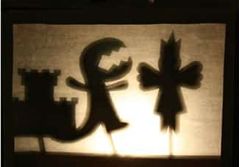

Year 3: Spring Term
Prehistoric Art
Lesson | Outline | Outcome
Painting: Tints and Shades | Learning that a 'tint' is made by adding white to a colour and a 'shade' by adding black, children mix their own colours to paint the outline of an animal, working across the image from light to dark and completing a contrasting background. | 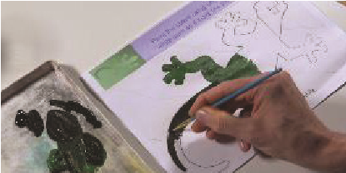
Exploring Prehistoric Art | Pupils reflect on the purpose of cave art paintings and introduce a sense of proportion when drawing an animal. | 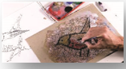  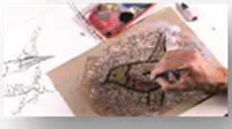
Charcoal Animals | Pupils scale up drawings in charcoal to create a variety of tones and textures. | 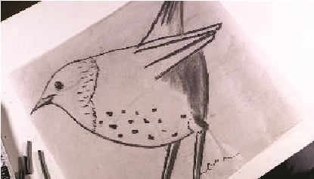
Prehistoric Palette | Pupils experiment with spices and natural materials to make paint, exploring the colours and effects that can be created. | 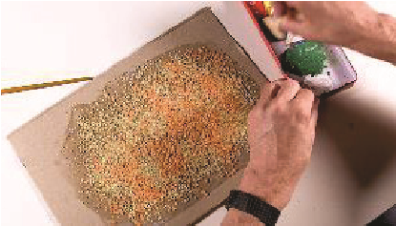
Painting on the Cave Wall | Pupils apply their painting skills to recreate a prehistoric picture on a textured surface.
Hands on a  Cave Wall | Pupils create hand prints on a textured background as a collaborative class piece of prehistoric-inspired art. | 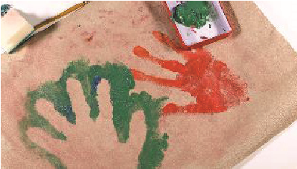

Year 3 Spring Term
Ideas to Support Your Child’s Learning at Home
Tertiary Colours:
Tertiary colours are produced by mixing equal amounts of a primary colour with a secondary colour adjacent to it on the colour wheel.
Complementary Colours:
Complementary colours are two colours that are on opposite sides of the colour wheel.
Proportion
The relationship between the sizes of different parts of a drawing or object; how big or small things are compared to each other.
Scaled up
When an object, drawing, or design is enlarged while keeping the same proportions.
Smudging
A technique where lines or tones are softened or blended by rubbing charcoal, pencil, or pastel.
Pigment
The coloured powder used to make paint, chalk, or other colouring materials.
Composition
How the elements of an artwork (shapes, lines, colours, objects) are arranged within the space.

Talk about our key vocabulary at home.

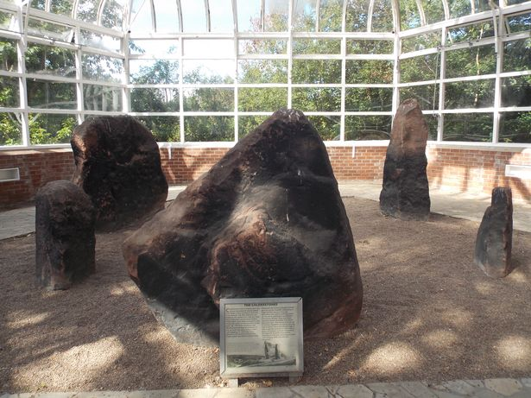

Visit the Harthill Greenhouses in Calderstones Park to view the ancient artwork adorning the sandstone monoliths.

Year 3 Spring Term
Ideas to Support Your Child’s Learning at Home
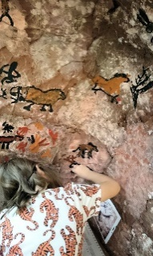
Support your child to create 3D cave art. Follow the link below for a prehistoric art project:
https://hannahsartclub.wordpress.com/2019/07/12/cave-art-in-3d-a-prehistoric-painting-experience/

Work with your child to freely create a piece of artwork, applying their newly developed skills.

Support your child to create prehistoric-inspired handprints. Follow the link below for a step-by-step guide:
https://www.dltk-kids.com/world/australia/handart.htm
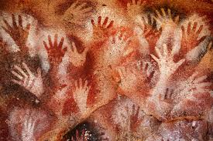

Year 3: Summer Term
Craft
Lesson | Outline | Outcome
Creating a  Mood Board | Children make a mood board by carefully selecting and curating fabrics, colours, textures and images to inspire them in this topic. | 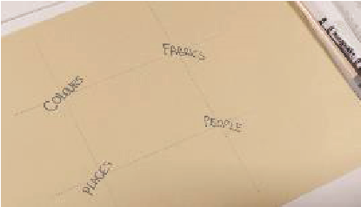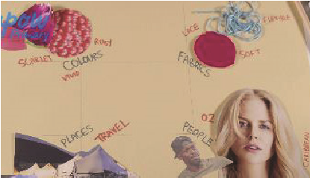
Tie-dyeing Materials  (2 Lessons) | Children learn how to create patterns on materials using tie-dye, exploring different effects. | 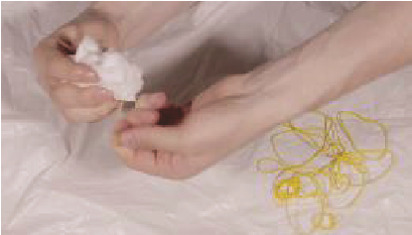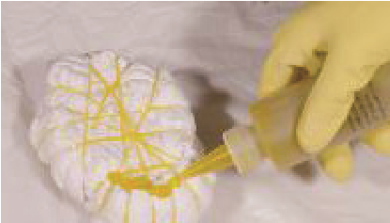
Paper Weaving | Children explore how to use strips of paper to create a weave, familiarising themselves with terms such as warp and weft. | 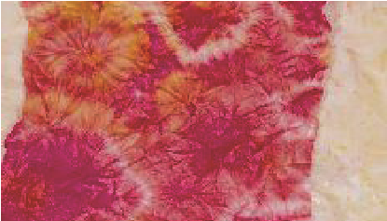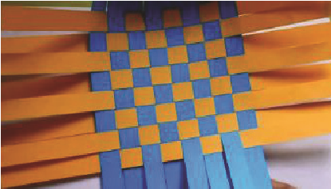
Weaving Other Materials | Using their weaving skills from the previous lesson and their tie-dyed materials from Lesson 2, children weave with fabric using a loom. | 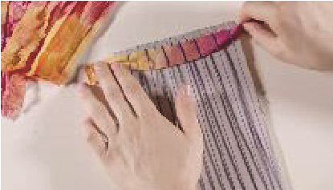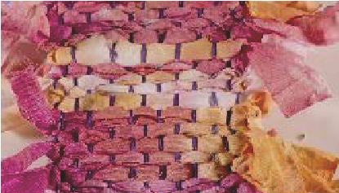

Year 3 Summer Term
Ideas to Support Your Child’s Learning at Home
Talk about our key vocabulary at home.
Mood Board:
A mood board is a combination of images, fonts, colors, and textures that define the style of a project.
Intersect:
To pierce or divide by passing through or across.
Tie-dyeing:
To produce patterns in a piece of cloth by tying parts of it to shield from dye.
Natural Material:
Any products that comes from plants, animals, or the ground e.g. wood.
Synthetic Material:
Any products made from man-made rather than natural fibers e.g. plastic.
Warp and Weft:
The weaving terms for the directionality of the threads that make up a woven fabric.

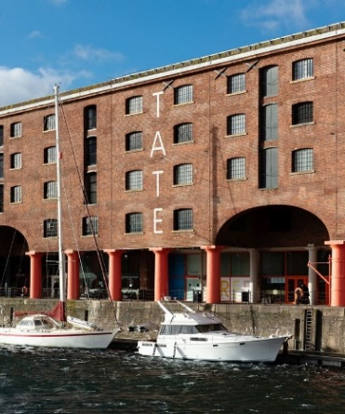

Visit the Tate Liverpool to view textile art including Anni Albers’ woven designs e.g. ‘Ancient Writing’.

Year 3 Summer Term
Ideas to Support Your Child’s Learning at Home
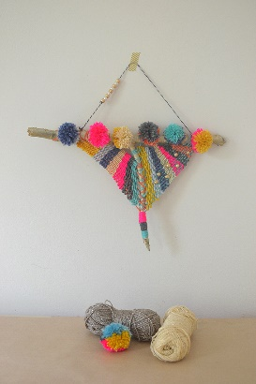
Support your child to create textile art using the technique of weaving. Follow the link below for a range of projects:
https://artfulparent.com/fabric-arts-and-crafts-ideas-for-kids/

Support your child to practise weaving using fabric strips and a homemade cardboard loom.
Cut a rectangle of cardboard.
Make small cuts along the top and bottom edges.
Stretch wool or string between the cuts to make the loom.
Help your child weave fabric strips over and under the strings.
Keep going until the weaving is complete.

