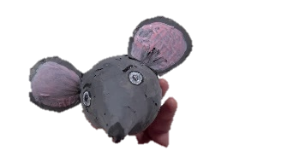
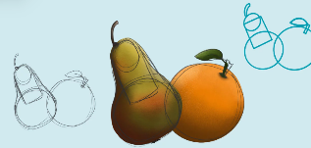
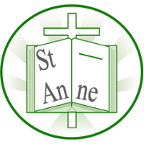
Vocabulary
Year 3
Art and Design: Sketching and Sculpture
Knowledge

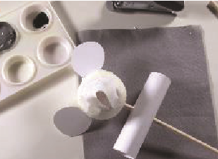
Geometric:
Shapes with straight lines or smooth curves like squares, triangles, and circles.
Organic:
Shapes found in nature, often uneven and curvy, such as a leaf or cloud.
Refine:
To improve something by continuously making minor changes.
Tone:
How light or dark a colour or area appears.
Even Tones:
Shading that appears smooth.
Craft:
To make something with your hands.
3D:
Something that has height, width, and depth.

I know that artists often begin drawings using simple geometric shapes to map out proportions and composition.
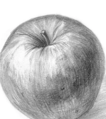
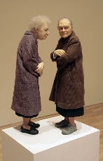
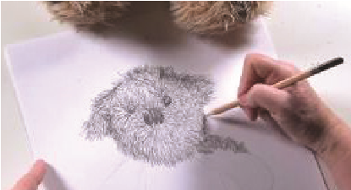
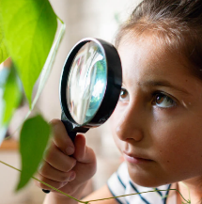
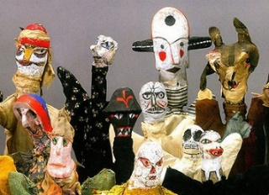
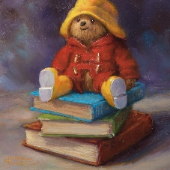
Ron Mueck #
I know that combining different materials (e.g., polystyrene, card, felt) allows artists to create three-dimensional forms and mixed-media artwork.
I know that mark-making techniques (e.g., hatching, cross-hatching, stippling) can be used to represent different textures in drawing.
I know that observation helps artists notice fine details such as patterns, textures, and subtle tone changes, which improve the accuracy of their drawings.
I know that tonal shading can be used to create the illusion of depth, with darker tones suggesting shadow and lighter tones suggesting highlights.
The Teddy Bear Gallery (2018-2020) by British artist Amanda Jackson.
‘Two Women’ (2005) by Australian artist Ron Mueck.
Puppets (1916-1925) by Swiss artist Paul Klee.

Inspirational Works

