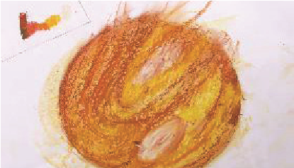
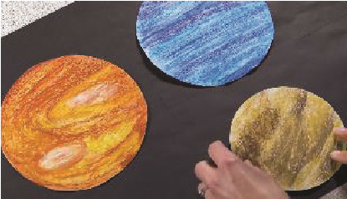
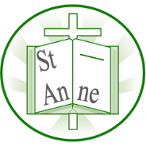
Vocabulary
Year 2
Art and Design: Sculpture and Mixed Media
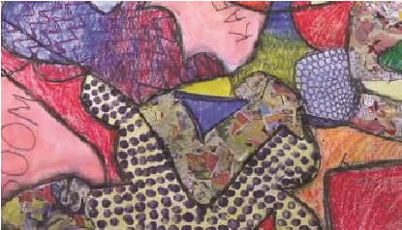
Techniques
Blend/Smudge:
Blending is the intermingling of colors to create a gradual transition. Smudging is the rubbing, dabbing or swiping of a medium in a smeary manner.
Opaque/Transparent:
A material is opaque if light cannot pass through it.
A material is transparent if light can pass through it.
Mannequin:
A mannequin is a doll representing the human figure.
Proportion:
Proportion refers to the relative size of the parts of a design.
Scale:
Scale refers to the size of an object in relation to another object.
Balance:
Balance refers to how the formal elements of art relate to each other within a composition.
I know how to use a range of mediums to create colourful tones, using these tones to make a drawing look three dimensional.

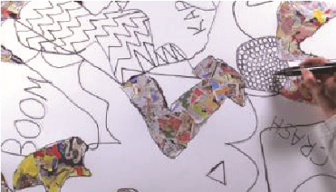
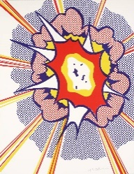
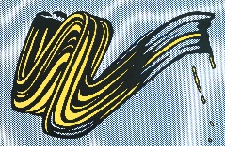
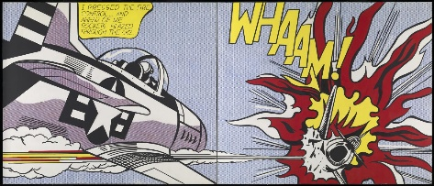
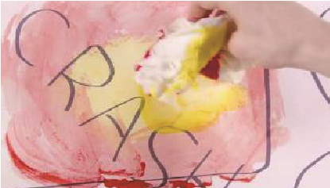
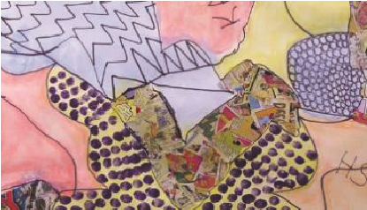
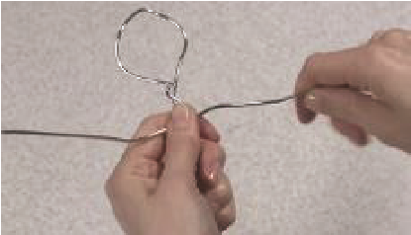
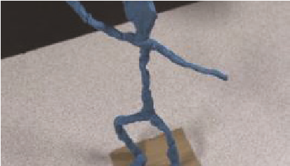
I know how to create a composition with figures, splashes and action words, adding texture and pattern to my piece in the style of artist Roy Lichtenstein.
I know how to blend pastel colours in sections and apply a black shadow highlight to make figures stand out.
I know how to work a colour wash into a piece and apply a dot matrix effect, similar to that of Roy Lichtenstein's. ‘Explosion’.
‘Explosion’ (1965)
‘Brush Stokes’ (1965)
Exploring pop art through the work of American artist Roy Lichtenstein
‘Whaam!’ (1963)
I know how to sketch a person before using wire and plasticine to turn my drawings into a three dimensional form.

Inspirational Works

