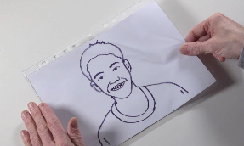
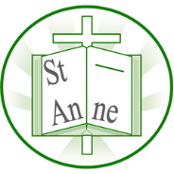
Year 2
Art and Design: Drawing with Expression
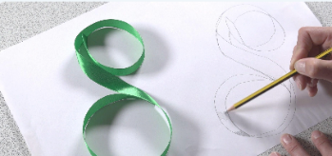
Knowledge
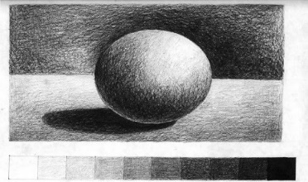
Vocabulary
Contrast:
A strong difference between things, such as light and dark or big and small.
Gradient:
A gradual change from one colour or tone to another.
Observational Drawing:
A drawing made by carefully looking at a real object.
Pattern:
A design made by repeating shapes, lines, colours, or images.
Trace:
To draw over lines or shapes to copy them.
Self-Portrait:
A picture an artist makes of themselves.
Expression:
How feelings or ideas are shown in art, faces, or movement.
Illustrator:
An artist who creates pictures for books, stories, or information.

Julian Opie uses simple lines and shapes to create clear, recognisable portraits.
Tone can be used to make a flat drawing look three-dimensional.
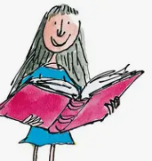
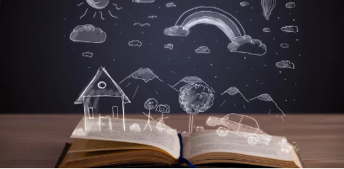
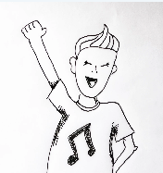
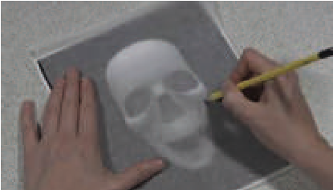
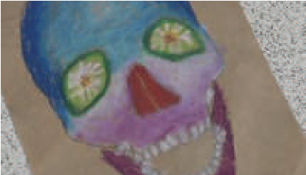
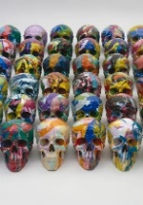
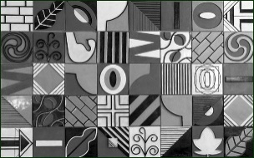
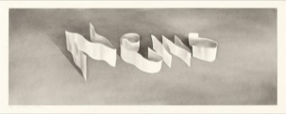
‘Matilda at 30’ (2018) by British illustrator Quentin Blake.
Illustrations can be arranged in sequence to tell a story through pictures.
Expressions and mark-making can afford personality traits to an illustrated character.
Shading creates lighter and darker tones to make drawings look more realistic.
Skulls in art can be decorated with patterns and designs inspired by different cultures.
‘Cornucopia’ (2008) by British artist Damien Hirst.
‘Ribbon Words’ (1966) by American artist Ed Ruscha.
‘Suite in Black, White and Grey’ (1992) by American artist Nancy McCroskey

Inspirational Works

