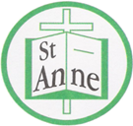

Year 2 Art and Design
Curriculum Booklet

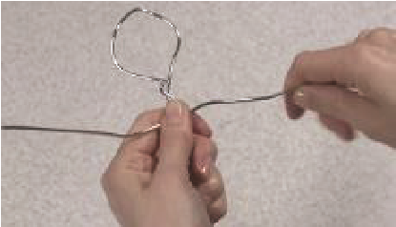
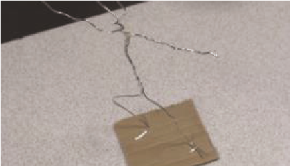
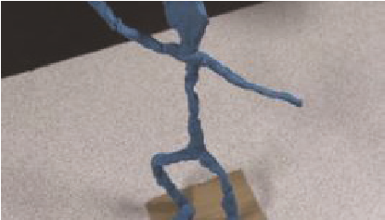

National Curriculum for Art and Design: Key Stage 1

The national curriculum for art and design aims to ensure that all pupils:
- produce creative work, exploring their ideas and recording their experiences
- become proficient in drawing, painting, sculpture and other art, craft and design techniques
- evaluate and analyse creative works using the language of art, craft and design
- know about great artists, craft makers and designers, and understand the historical and cultural development of their art forms.

Pupils should be taught:
- to use a range of materials creatively to design and make products
- to use drawing, painting and sculpture to develop and share their ideas, experiences and imagination
- to develop a wide range of art and design techniques in using colour, pattern, texture, line, shape, form and space
- about the work of a range of artists, craft makers and designers, describing the differences and similarities between different practices and disciplines, and making links to their own work.
Year 2: Autumn Term-
Patterns and Textures
Lesson | Outline | Outcome
Pattern: Repeating Patterns | Having looked at the patterns around them, pupils dip everyday objects in paint to create repeating patterns, varying the direction of the pattern and colours of the paint and paper. | 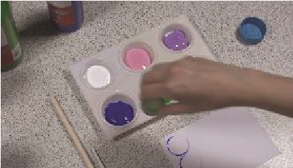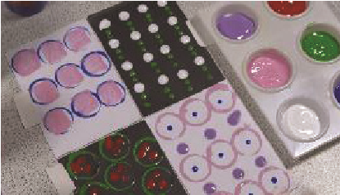
Weaving a Picture | Pupils learn the craft of weaving, overlapping coloured strips of paper to create a checkerboard, then selecting a shape to overlay onto the weave before decorating. | 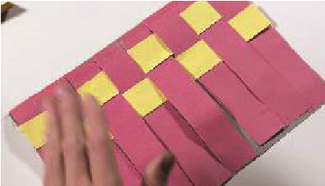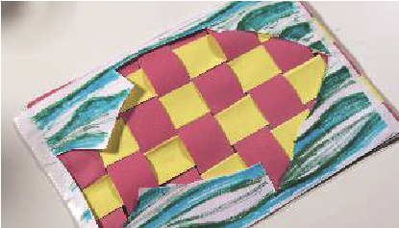
Taking Rubbings | Using media of their choosing, pupils go in search of textures that interest them to take rubbings of. | 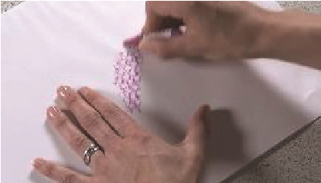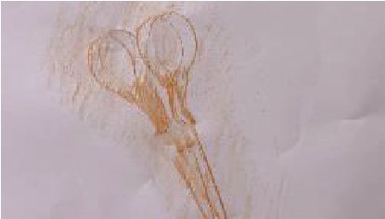
Frottage | Pupils are introduced to 'frottage', tearing their rubbings from the previous lesson to make pictures in the style of the artist who created the technique, Max Ernst. | 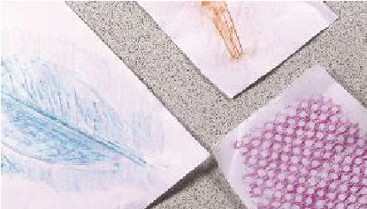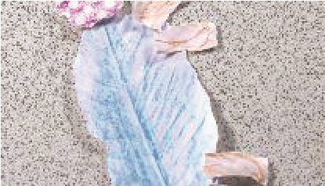
Exploring Clay | Pupils explore how clay can be shaped by hand and learn some basic skills to apply when making a simple model. | 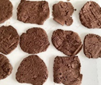  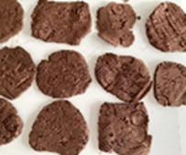
Pinch Pots | Pupils practise using the 'score and slip' clay joining technique before making their own pinch pot and decorating it by joining clay shapes. | 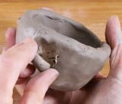
Year 2 Autumn Term:
Ideas to Support Your Child’s Learning at Home
Repeating Pattern:
A design where the same shapes, colours, or lines are repeated in the same order.
Motif:
A shape or picture that is repeated in a design.
Overlapping:
When one shape or object covers part of another.
Warp:
The straight threads in weaving that run up and down
Weft:
The threads in weaving that go across from side to side.
Malleable:
Easy to shape or bend without breaking.
Score:
To scratch lines into clay before joining pieces together.
Slip:
Wet clay used like glue to join pieces.

Talk about our key vocabulary at home.

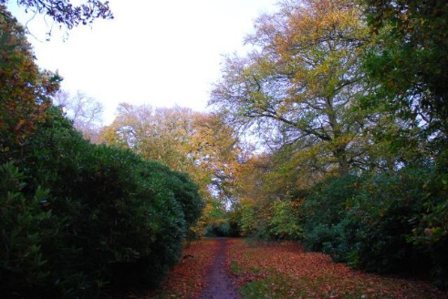

Visit Childwall Woods to explore texture in nature and take rubbings of trees and other textured surfaces.

Year 2 Autumn Term:
Ideas to Support Your Child’s Learning at Home
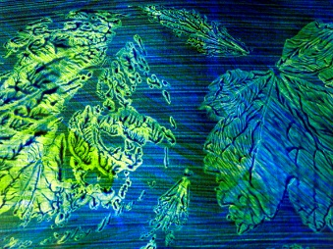
Support your child to create a piece of art using the technique of frottage. Follow the link below for a range of ideas:
https://artful-kids.com/2012/05/14/fun-with-frottage/

Work with your child to freely create a piece of artwork, applying their newly developed skills.

Support your child to create a piece of art using the technique of weaving. Follow the link below for a guide to paper weaving:
https://www.firstpalette.com/craft/paper-weaving.html
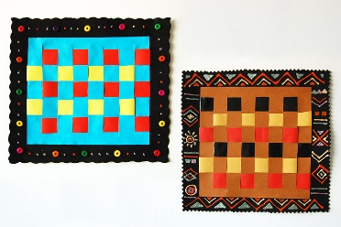

Year 2: Spring Term
Drawing with Expression
Lesson | Outline | Outcome
Shading | Working in the style of Nancy McCroskey’s mural, ‘Suite in Black, White and Grey’, pupils draw six boxes, filling each with a line that starts at one edge and finishes at another. Pupils then experiment with tone by shading the different areas they have made. | 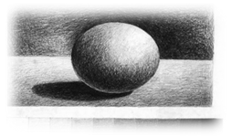
3D Pencil Drawings | Pupils use tone to make an observational line drawing look three dimensional together with exploring different gradients of pencil. | 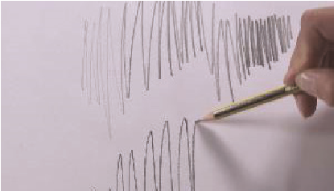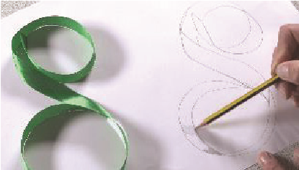
Skulls | Taking inspiration from decorated skulls in different cultures, pupils trace an image of a skull before decorating it using a medium and pattern of their choice. | 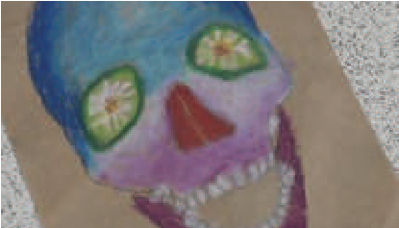
Opie Style Portraits | Pupils create a self-portrait using lines and dots, in the style of contemporary British artist, Julian Opie. | 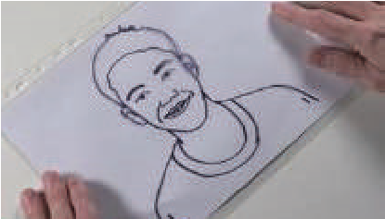
Creating Characters | Pupils develop new character illustrations, applying skills with line and mark making to add expression and detail. | 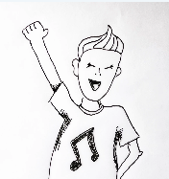
Tell a Story | Pupils make concertina books to illustrate with scenes for characters using mark making drawing techniques. | 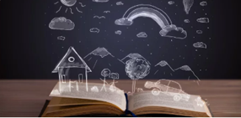

Year 2 Spring Term
Ideas to Support Your Child’s Learning at Home
Talk about our key vocabulary at home.
Repeating Pattern:
A design where the same shapes, colours, or lines are repeated in the same order.
Motif:
A shape or picture that is repeated in a design.
Overlapping:
When one shape or object covers part of another.
Warp:
The straight threads in weaving that run up and down
Weft:
The threads in weaving that go across from side to side.
Malleable:
Easy to shape or bend without breaking.
Score:
To scratch lines into clay before joining pieces together.
Slip:
Wet clay used like glue to join pieces.

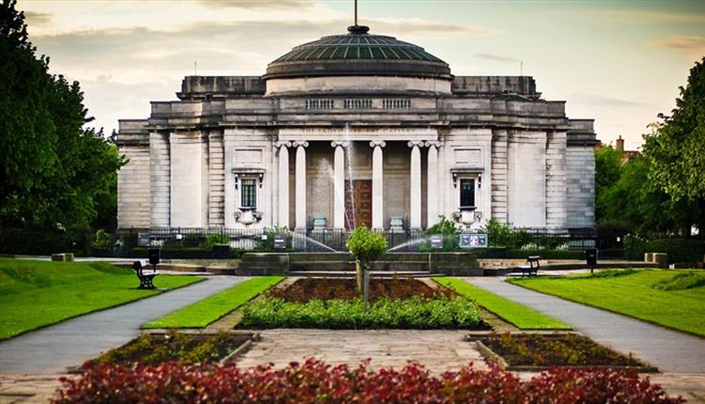

Visit the Lady Lever Art Gallery to view William Hesketh Lever's personal collection of portraits.

Year 2 Spring Term
Ideas to Support Your Child’s Learning at Home
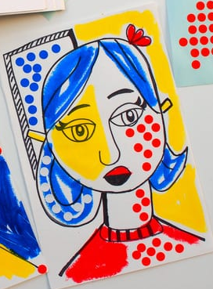
Support your child to create a self-portrait. Follow the link below for creative self-portrait projects:
https://www.hellowonderful.co/post/12-creative-self-portrait-art-projects-for-kids/

Work with your child to freely create a piece of artwork, applying their newly developed skills.

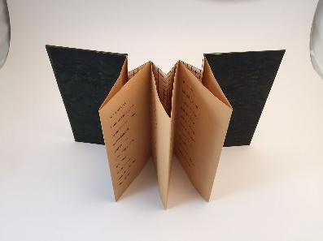
Support your child to develop storytelling and mark‑making skills by creating a simple concertina book at home.

Year 2: Summer Term
Sculpture and Mixed Media
Lesson | Outline | Outcome
3D Colour Drawings | Pupils use a range of mediums to create colourful tones, using these tones to make a drawing look three dimensional. | 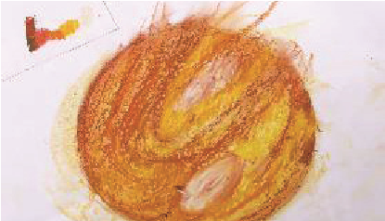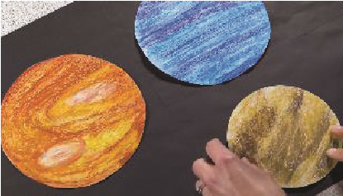
Superhero Figures  (2 Lessons) | Pupils sketch a person before using wire and plasticine to turn their drawings into a three dimensional form.
Multimedia Superheroes  Part 1 | Pupils create a composition with figures, splashes and action words, adding texture and pattern to their piece in the style of artist Roy Lichtenstein. | 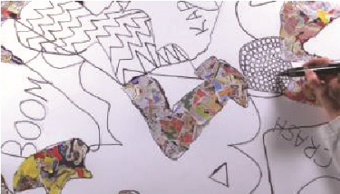
Multimedia Superheroes  Part 2 | Pupils work a colour wash into a piece and apply a dot matrix effect, similar to that of Roy Lichtenstein's ‘Explosion’. | 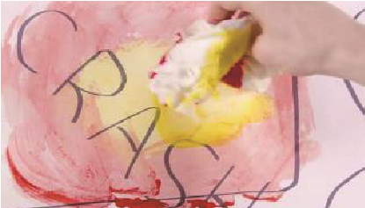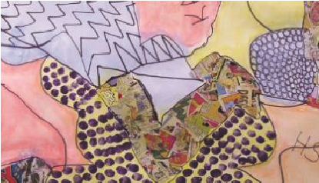
Multimedia Superheroes  Part 3 | Pupils blend pastel colours in sections and apply a black shadow highlight to make figures stand out, as inspired by artist Roy Lichtenstein. | 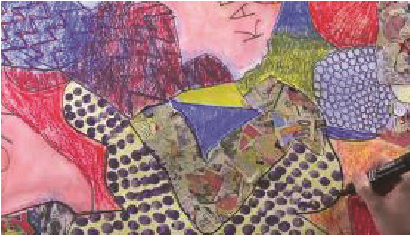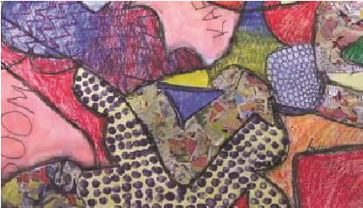

Year 2 Summer Term
Ideas to Support Your Child’s Learning at Home
Blend/Smudge:
Blending is the intermingling of colors to create a gradual transition. Smudging is the rubbing, dabbing or swiping of a medium in a smeary manner.
Opaque/Transparent:
A material is opaque if light cannot pass through it.
A material is transparent if light can pass through it.
Mannequin:
A mannequin is a doll representing the human figure.
Proportion:
Proportion refers to the relative size of the parts of a design.
Scale:
Scale refers to the size of an object in relation to another object.
Balance:
Balance refers to how the formal elements of art relate to each other within a composition.

Talk about our key vocabulary at home.

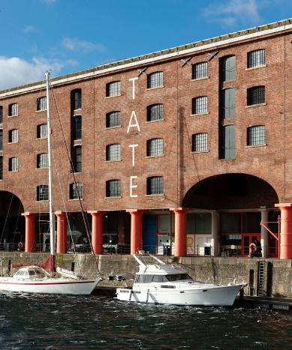

Visit the Tate Liverpool to view the work of Roy Lichtenstein (‘Whaam’).

Year 2 Summer Term
Ideas to Support Your Child’s Learning at Home

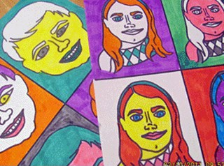
Support your child to create pop art, inspired by the artist Andy Warhol. Follow the link below for a range of pop art ideas:
https://artsycraftsymom.com/10-andy-warhol-projects-for-kids/

Work with your child to freely create a piece of artwork, applying their newly developed skills.

Support your child to create 3D models using playdough and other materials. Follow the link below for a guide to making playdough figures:
https://www.wikihow.com/Make-a-Clay-Person
