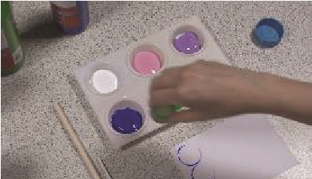
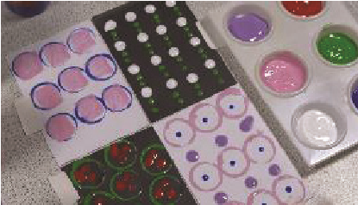
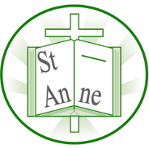
Vocabulary
Year 2
Art and Design: Patterns and Textures
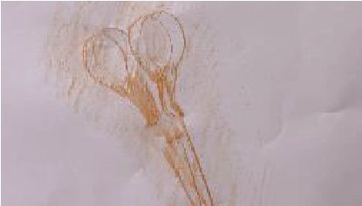
Knowledge
I know that a repeating pattern is a design where shapes, lines, or colours are repeated in the same order.
I know that a rubbing is made by placing paper over a textured surface and rubbing with a drawing tool to show the pattern of the texture underneath.
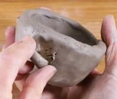
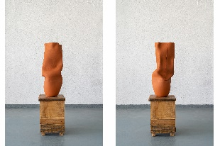
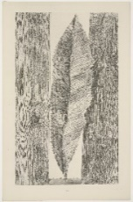
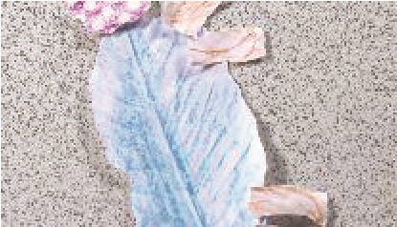
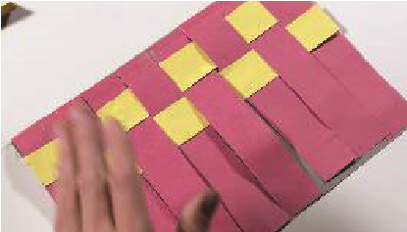
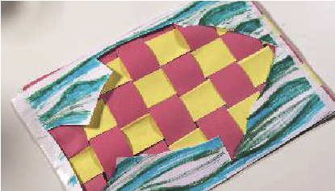
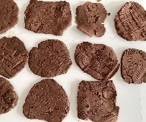
‘The Habit of Leaves’ (1925) by German artist Max Ernst.
‘Common Ground’ by British-Nigerian ceramic artist Ranti Bam.
‘The Entire City’ (1934) by German artist Max Ernst.

I know that a pinch pot is made by shaping clay with your fingers and thumbs to form a small bowl.
Inspirational Works
I know that clay is a soft material that can be shaped by hand and will harden when left to dry.
I know that frottage is an art technique where rubbings of textures are torn and arranged to create a picture.
I know that weaving is a process of crossing strips of material over and under each other to make a pattern.

Repeating Pattern:
A design where the same shapes, colours, or lines are repeated in the same order.
Motif:
A shape or picture that is repeated in a design.
Overlapping:
When one shape or object covers part of another.
Warp:
The straight threads in weaving that run up and down
Weft:
The threads in weaving that go across from side to side.
Malleable:
Easy to shape or bend without breaking.
Score:
To scratch lines into clay before joining pieces together.
Slip:
Wet clay used like glue to join pieces.

