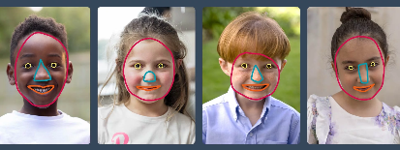
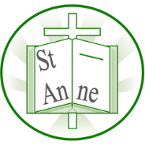
Vocabulary
Year 1
Art and Design: Sculpture
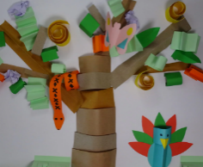
Knowledge
Sculpture
A work of art that is made in three dimensions and can be viewed from all sides. It is created by shaping or combining materials.
Three-dimensional
Describes art that has height, width and depth, such as sculpture.
Fold
To bend a material, such as paper or card, over itself to create a crease.
Overlap
To place one shape or form so that it partly covers another.
Spiral
A curved form that winds around a central point or axis, twisting outward or inward.
Zigzag
A line or pattern made up of short diagonal lines that alternate direction.
Scrunch
To press and squeeze material together so it becomes wrinkled or compact.

Abstract
Art that does not try to show objects or people as they look in real life, using shapes, lines and colours instead.
nsead.org

Feature
A part of a face or object that helps to define it, such as eyes, nose or mouth in a portrait.

Portrait
A picture or artwork that shows a person, especially their face and expression.

Sketch
A simple, quick drawing that captures the basic shape or idea of something.
Basic shapes and lines are used in artwork to help form images, including faces and portraits.
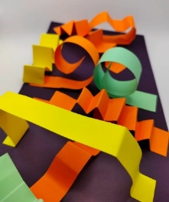
Paper-shaping skills can be applied to create imaginative sculptures inspired by ideas, stories, or mythology.
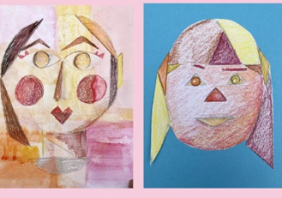
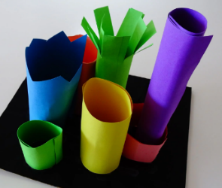
Paper can be folded, rolled, and shaped to create three-dimensional forms that stand up from a flat base.
Different pressures and colouring techniques can be used to add colour, tone, and expression to a portrait inspired by artist Paul Klee.
Rolling paper can create strong cylindrical shapes that can be joined together to form simple 3D structures.
‘Senecio’ (1922) by Swiss-German painter Paul Klee.
‘Other’ (2014) by British sculptor and paper artist Samantha Stephenson.
‘Tree of Life’ (2015) by Italian installation artist Marco Balich.

Inspirational Works

