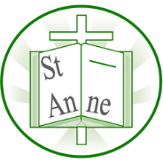
Year 1
Art and Design: Landscapes using Different Media
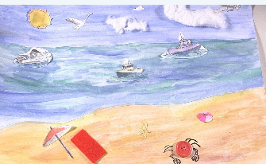
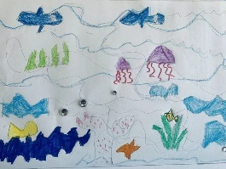
Knowledge

Lines:
Long, thin marks that can be straight, curved, zigzag, vertical, horizontal, or diagonal.
Texture:
The way something feels to touch, or looks to the eye.
Tone:
The lightness or darkness of something.
Tint:
A colour mixed with white to make it lighter.
Shade:
A colour mixed with black to make it darker.
Collage:
An artwork made by sticking different materials onto a surface, such as paper, fabric or photos.
Vocabulary
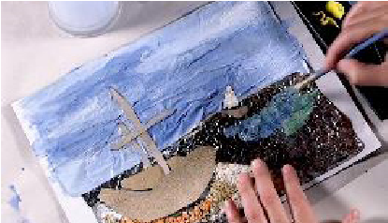
Lines can show movement and energy, like the movement of water.
Collage combines different materials and painted elements to add detail and depth to an artwork.

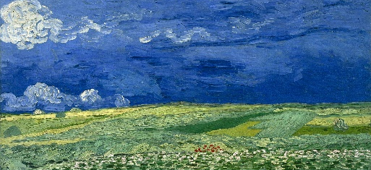
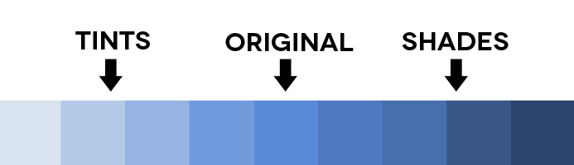
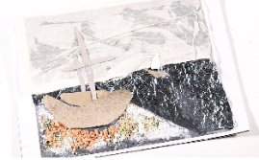
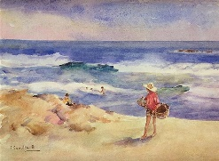
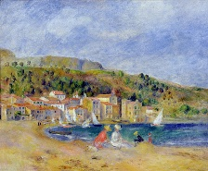
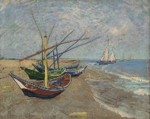
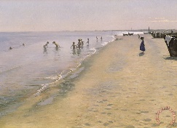
Artists layer colour on top of texture to make their work more interesting and expressive.
Different materials and marks can be used to represent textures such as rough sand, smooth shells, or foamy waves.
Tints are made by adding white, shades by adding black, and hues are different colours.
A landscape has a foreground, middle ground and background, and the horizon line separates the land/sea from the sky.
Fishing Boats on the Beach at Saintes-Maries-de-la-Mer (1888) by Danish artist Vincent van Gogh.
Summer Day at the South Beach of Skagen (1893) by Danish artist Peder Severin Krøyer.

Inspirational Works

