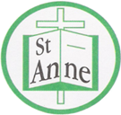

Year 1 Art and Design
Curriculum Booklet

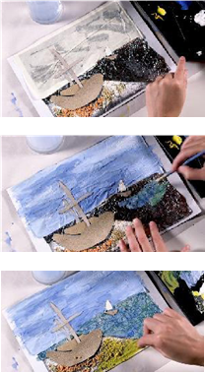

National Curriculum for Art and Design: Key Stage 1

The national curriculum for art and design aims to ensure that all pupils:
- produce creative work, exploring their ideas and recording their experiences
- become proficient in drawing, painting, sculpture and other art, craft and design techniques
- evaluate and analyse creative works using the language of art, craft and design
- know about great artists, craft makers and designers, and understand the historical and cultural development of their art forms.

Pupils should be taught:
- to use a range of materials creatively to design and make products
- to use drawing, painting and sculpture to develop and share their ideas, experiences and imagination
- to develop a wide range of art and design techniques in using colour, pattern, texture, line, shape, form and space
- about the work of a range of artists, craft makers and designers, describing the differences and similarities between different practices and disciplines, and making links to their own work.
Year 1: Autumn Term- Colour in Different Media
Lesson | Outline | Outcome
Experimenting with Media | Inspired by famous abstract artists, including Kandinsky, children draw around and overlap 2D shapes to create an abstract composition, filling each shape with a different colour and medium. | 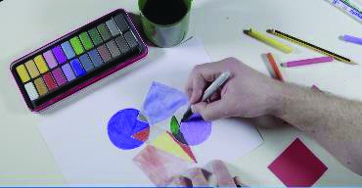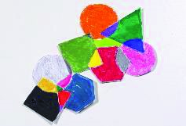
Printing with Paint | Pupils will use building blocks and other everyday objects to create prints; painting and stamping their blocks to create patterns, pictures and letters and combining colours on the page, explaining the choices they make. | 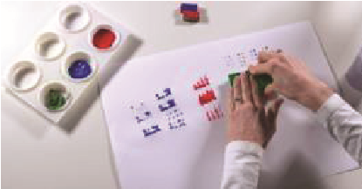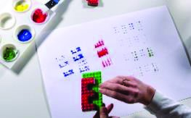
Making Colours | Pupils will identify primary colours and explore how secondary colours can be mixed. | 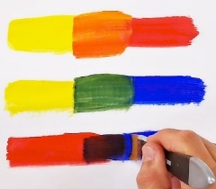
Painting with Colour | Pupils put their understanding of colour mixing into practice to recreate their own versions of the artwork '0-9' by artist Jasper Johns. | 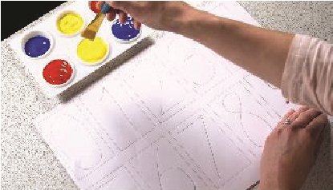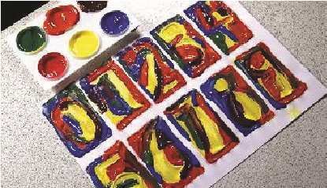
Exploring Colour Mixing | Pupils will mix two primary colours to create different shades of a secondary colour and using these in a decorative painting. | 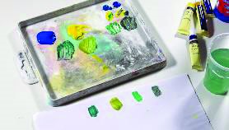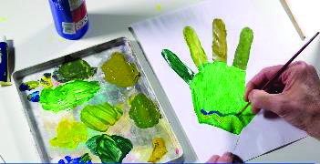
Clarice Cliff Plates | Using paper plates, pupils will recreate their own designs of Clarice Cliffs ‘Circle Tree’ plate, using bright colours to paint circles and finishing by using black paint and a straw to blow a tree design. | 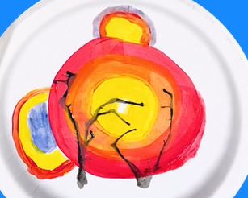  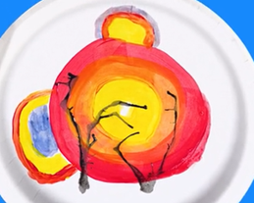

Year 1 Autumn Term:
Ideas to Support Your Child’s Learning at Home
Abstract:
A picture that doesn’t look exactly like real life but uses shapes, colours, and lines to show ideas or feelings.
Medium:
The materials an artist uses to make art, such as pencils, crayons, paint and clay.
Shade:
How light or dark a colour is.
Pattern:
A design that repeats, like stripes, dots, or zigzags.
Texture:
How something feels when you touch it such as bumpy, soft, or smooth.
Blend:
To mix colours together so they join smoothly.
Hue:
The specific shade of a colour for example sky blue and navy are different hues of blue.
Talk about our key vocabulary at home.

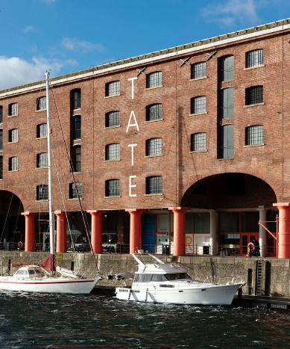

Visit the Tate Liverpool to view the work of Jasper John (‘0-9’) and Wassily Kandinsky (‘Squares with concentric circles’).

Year 1 Autumn Term:
Ideas to Support Your Child’s Learning at Home
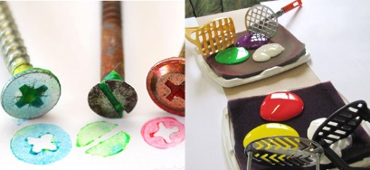
Support your child to explore their printing skills using household objects. Follow the link below for a range of printing projects:
https://tinkerlab.com/printmaking-for-kids/

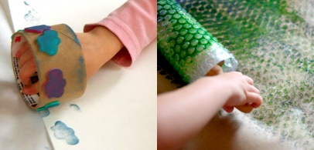

Work with your child to freely create a piece of artwork, applying their newly developed skills.

Support your child to explore primary and secondary colours. Follow the link below for a range of colour mixing activities:
https://artfulparent.com/color-mixing-activities-for-kids/

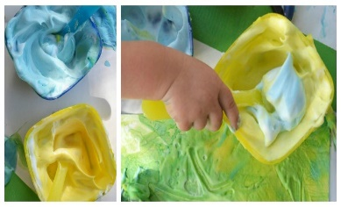

Year 1: Spring Term
Landscapes Using Different Media
Lesson | Outline | Outcome
Making Waves | Pupils explore expressive lines using music to create a large collaborative piece inspired by water and the artwork of Zaria Forman. | 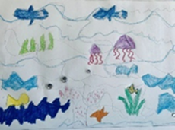  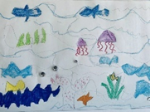
Composition – Seaside Landscape | Pupils apply the principle of composition to represent the horizon and tide lines in landscape artwork, inspired by artists Renoir, Sorolla and Krøyer. | 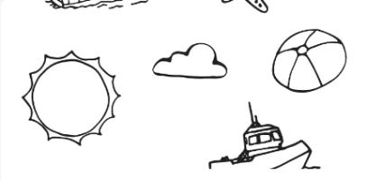
Beach Textures | Pupils use a range of materials to replicate the textures found at the seaside. | 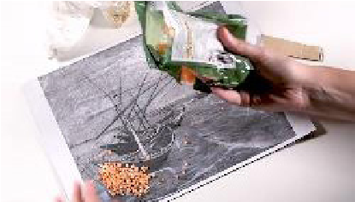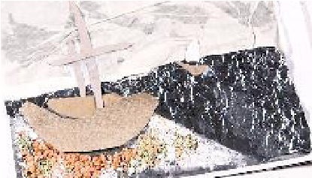
Shades and Colours of the Sea | Pupils create different tints, shades and hues to paint the background of their seaside scene. | 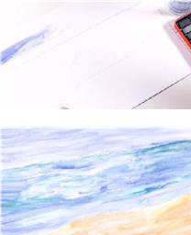  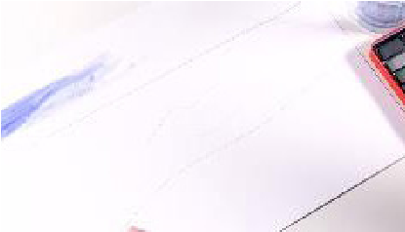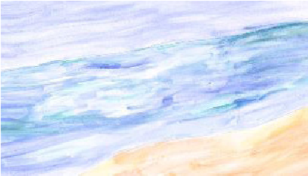
Painting over Texture | Over the top of their textured background, pupils add colour using poster paints to complete their pictures. | 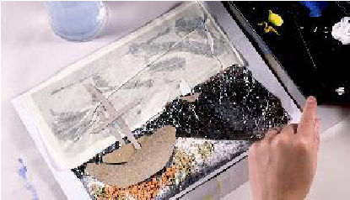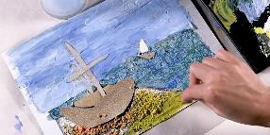
Beach Collage | Using their painted backgrounds from a previous lesson, pupils add objects and images, further adding detail and shading. | 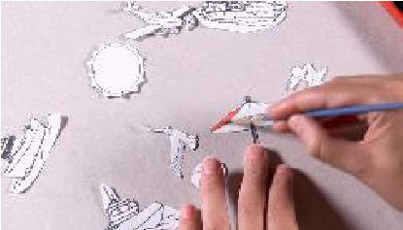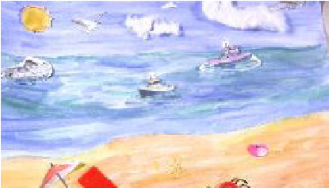

Year 1 Spring Term
Ideas to Support Your Child’s Learning at Home
Lines:
Long, thin marks that can be straight, curved, zigzag, vertical, horizontal, or diagonal.
Texture:
The way something feels to touch, or looks to the eye.
Tone:
The lightness or darkness of something.
Tint:
A colour mixed with white to make it lighter.
Shade:
A colour mixed with black to make it darker.
Collage:
An artwork made by sticking different materials onto a surface, such as paper, fabric or photos.

Talk about our key vocabulary at home.

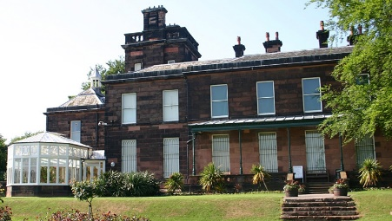

Visit Sudley House to view landscape art by Henry William Banks Davis (‘The Evening Star’) and Thomas Creswick (‘The Windmill’).

Year 1 Spring Term
Ideas to Support Your Child’s Learning at Home
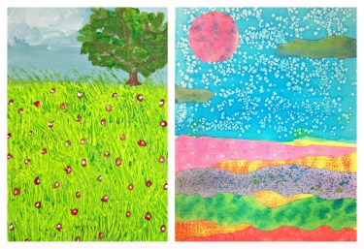
Support your child to explore landscape art. Follow the link below for a collection of creative landscape projects:
https://thepinterestedparent.com/2018/07/beautiful-landscape-projects-for-kids/

Work with your child to freely create a piece of artwork, applying their newly developed skills.

Support your child to create landscape collages. Follow the link below to learn how to use texture and colour to create landscape art:
https://www.bbc.co.uk/teach/class-clips-video/art-and-design-using-textured-materials-landscape-collage/zfrfbdm
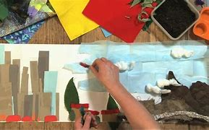

Year 1: Summer Term
Sculpture
Lesson | Outline | Outcome
Tube Towers | Pupils investigate how rolling paper can create 3D structures, before designing a simple sculpture using paper cylinders. | 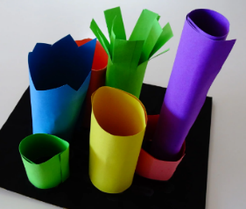
3D Drawings | Pupils fold and roll paper to make a 3D drawing. Pupils consolidate skills by manipulating this material to create 3D forms. | 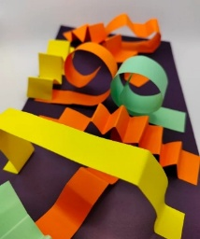
Tree of Life | Pupils evaluate artworks inspired by Tree of life mythology, applying their paper-shaping skills to create an imaginative sculpture. | 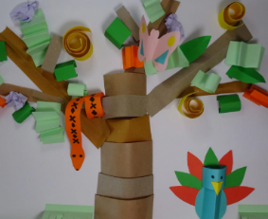  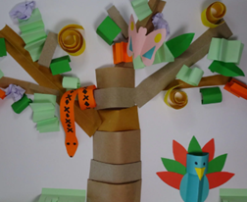
Shape in Art | Pupils recognise basic shapes in objects and artwork and begin to understand how they help to form drawings. Pupils apply this knowledge to begin drawing a portrait inspired by Paul Klee's Senecio. | 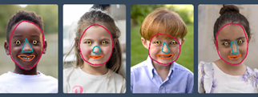
Klee Portraits | Pupils develop control of tools and materials to colour portrait drawings inspired by Paul Klee. | 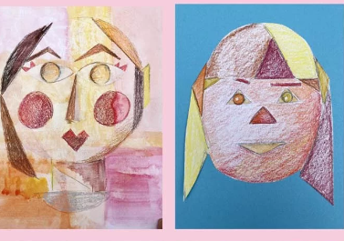  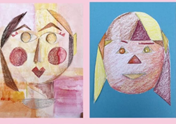

Year 1 Summer Term
Ideas to Support Your Child’s Learning at Home
Sculpture
A work of art that is made in three dimensions and can be viewed from all sides. It is created by shaping or combining materials.
Three-dimensional
Describes art that has height, width and depth, such as sculpture.
Fold
To bend a material, such as paper or card, over itself to create a crease.
Overlap
To place one shape or form so that it partly covers another.
Spiral
A curved form that winds around a central point or axis, twisting outward or inward.
Zigzag
A line or pattern made up of short diagonal lines that alternate direction.
Scrunch
To press and squeeze material together so it becomes wrinkled or compact.

Talk about our key vocabulary at home.

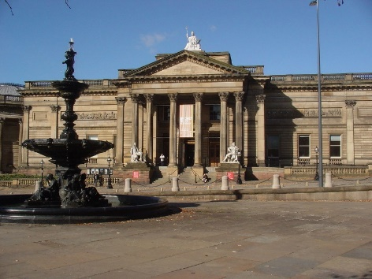

Visit the Walker Art Gallery to view the sculpture collection, particularly known for its outstanding display of works made between the 18th century and the First World War.

Year 1 Summer Term
Ideas to Support Your Child’s Learning at Home
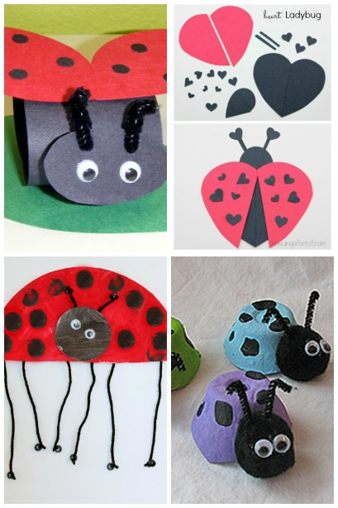
Support your child to create sculptures of ladybirds using cardboard. Follow the link below for a range of sculpture ideas:
http://www.housingaforest.com/ladybug-craft-ideas/

Work with your child to freely create a piece of artwork, applying their newly developed skills.

Support your child to create a sculpture from salt dough. Follow the link below for a salt dough recipe and sculpture ideas:
https://theimaginationtree.com/salt-dough-hand-print-butterfly-keepsake/
