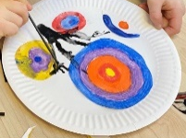
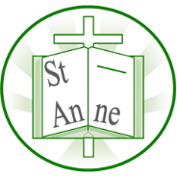
Vocabulary
Year 1
Art and Design: Colour in Different Media
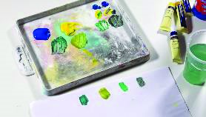
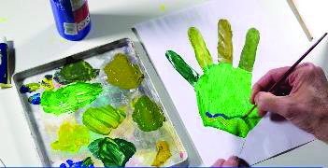
Knowledge
I know that Clarice Cliff was a British ceramic artist who painted onto pottery such as plates.
I know that mixing different amounts of the same two primary colours can create a range of shades of the same secondary colour.
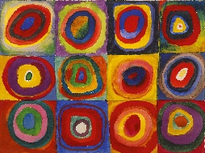
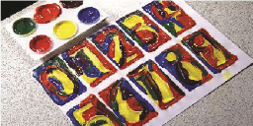
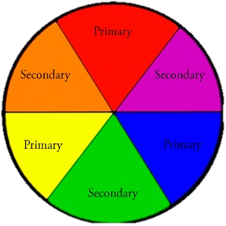
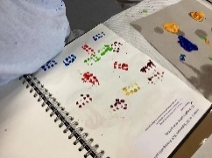
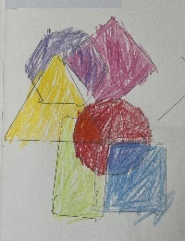
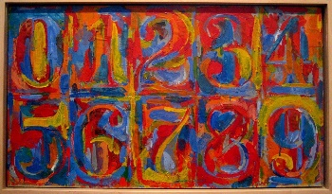
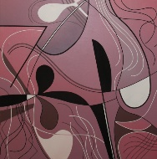
I know that the three primary colours (red, yellow, blue) can be mixed together in pairs to create secondary colours (e.g. orange, green, purple).
I know that printing is a process where paint is applied to a surface (block, object, or stamp) and transferred to another surface to create a repeated image or pattern.
I know that different media (e.g., pencil, crayon, paint, collage materials) can be combined to create abstract compositions.

Abstract:
A picture that doesn’t look exactly like real life but uses shapes, colours, and lines to show ideas or feelings.
Medium:
The materials an artist uses to make art, such as pencils, crayons, paint and clay.
Shade:
How light or dark a colour is.
Pattern:
A design that repeats, like stripes, dots, or zigzags.
Texture:
How something feels when you touch it such as bumpy, soft, or smooth.
Blend:
To mix colours together so they join smoothly.
Hue:
The specific shade of a colour for example sky blue and navy are different hues of blue.
‘0-9’ (1960) by American artist Jasper Johns.
‘Squares with concentric circles’ (1913) by Russian artist Wassily Kandinsky.
‘Red Mardi Gras’ (1965) by American artist Renata Bernal.

Inspirational Works

