

Mathematics Home Learning
In Reception, children are introduced to the concept of zero by exploring situations where there is nothing or none. Children may initially use informal language such as “nothing there” or “all gone” to describe what they notice.
We then introduce mathematical language to support their understanding of zero, including “zero”, “none” and “empty”. Children learn that zero represents no objects and can be used as a number to describe an empty set. Through practical activities, children begin to recognise and use the numeral 0 to represent zero.
When using physical resources, it is important to support children’s understanding that zero means there are no objects to count. Please scan the QR code below to watch the home learning video on the topic of “Introducing Zero” before completing the attached follow-up activity.
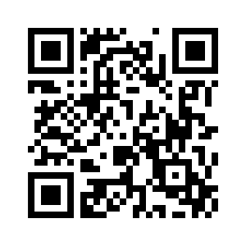

Home Learning Video

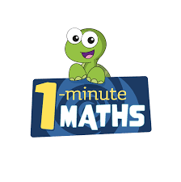

White Rose Maths have created an app called 1-Minute Maths. The app aims to help children build
greater number confidence and fluency through targeted practice in engaging, one-minute
chunks. Your child can choose any topic they want to try. They then answer a unique series of questions
(a different set of questions is generated each time). If they’re finding a question tricky, a ‘hint’
button will give a helpful clue by showing the question in a different way for example. When the

one minute is up, you will see a feedback screen detailing your child’s score. You can use this to move your child’s learning forward. The 1 Minute Maths app requires no login or internet access. It is free to download and available at:

