

Mathematics Home Learning
In Reception, children are introduced to comparing mass by exploring how objects can be balanced, compared and ordered. Children investigate which object is heavier, which is lighter, and when two objects have the same mass. They are introduced to mathematical language to support their understanding of comparison, including terms such as heavy, light, heavier than, lighter than, the same, equal, balance and compare. Children learn that mass is about how heavy or light an object feels, not just how big it looks. Through practical activities, they begin to understand that mass can be compared directly by holding objects or by using balance scales. They also start to recognise that objects can be ordered from lightest to heaviest.

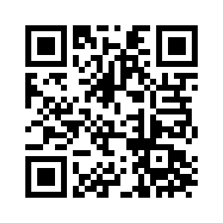
You can support your child’s understanding by showing them how to become a human balance scale. Your child can hold one object in each hand, stretch their arms out, and notice which arm goes down. The arm that is weighed down more is holding the heavier object, and the arm that is weighed down less is holding the lighter object. Encourage your child to explain what they notice, for example: “This arm is lower because it is heavier,” or “My arms are level because they are the same.” Please scan the QR code below to watch the home learning video on the topic of “Comparing Mass and Balance” before completing the attached follow-up activity.
Home Learning Video

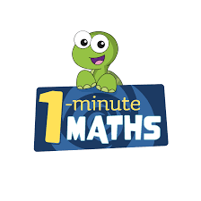

White Rose Maths have created an app called 1-Minute Maths. The app aims to help children build
greater number confidence and fluency through targeted practice in engaging, one-minute
chunks. Your child can choose any topic they want to try. They then answer a unique series of questions
(a different set of questions is generated each time). If they’re finding a question tricky, a ‘hint’
button will give a helpful clue by showing the question in a different way for example. When the
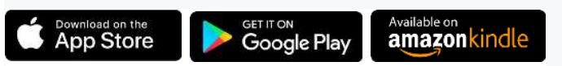
one minute is up, you will see a feedback screen detailing your child’s score. You can use this to move your child’s learning forward. The 1 Minute Maths app requires no login or internet access. It is free to download and available at:

