

Mathematics Home Learning
In Reception, children are introduced to comparing numbers to 5 by exploring how amounts can be matched, compared and ordered. Children investigate which number is more, which is less, and when two groups have the same amount. Children are introduced to mathematical language to support their understanding of comparison, including terms such as “more”, “less”, “fewer”, “same”, “equal”, “greater than”, “smaller than” and “compare”. They also begin to use language such as “one more” and “one less” to describe how numbers change. Children learn that numbers to 5 can be compared by looking at the quantity, not just the numeral. Through practical activities, they begin to recognise that numbers are linked in order, and that each number is one more than the one before it, and one less than the one after it.
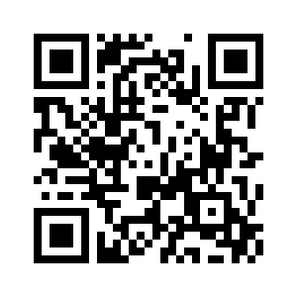
You can use household items, for example placing two bowls of apples side by side (e.g., 3 apples in one bowl and 5 apples in another), to support children’s understanding of comparison. Encourage your child to explain what they notice, for example: “This bowl has more because it has 5 and the other has 3.” You could also match objects one-to-one to check which group has more, or if they are equal. Please scan the QR code below to watch the home learning video on the topic of “Comparing Numbers to 5” before completing the attached follow-up activity.

Home Learning Video

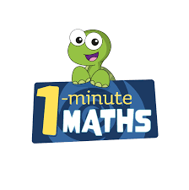

White Rose Maths have created an app called 1-Minute Maths. The app aims to help children build
greater number confidence and fluency through targeted practice in engaging, one-minute
chunks. Your child can choose any topic they want to try. They then answer a unique series of questions
(a different set of questions is generated each time). If they’re finding a question tricky, a ‘hint’
button will give a helpful clue by showing the question in a different way for example. When the

one minute is up, you will see a feedback screen detailing your child’s score. You can use this to move your child’s learning forward. The 1 Minute Maths app requires no login or internet access. It is free to download and available at:

