

Mathematics Home Learning
In Reception, children are introduced to the composition of 5 by exploring how numbers can be made up of smaller parts. Children investigate different ways to make 5 using practical resources, for example noticing that 5 can be made from 2 and 3, or 4 and 1. The children are introduced to mathematical language to support their understanding of composition, including terms such as “whole”, “parts”, “altogether” and “equals”.

Children learn that 5 is a whole number that can be composed in different ways using two or more parts, and that these parts always combine to make the same total. Through practical activities, children begin to recognise and recall the different ways to make 5. You can use household items, e.g., 5 apples partitioned into 2 bowls, to support children’s understanding that the total remains 5, even when it is split in different ways. Please scan the QR code below to watch the home learning video on the topic of “Composition of 5” before completing the attached follow-up activity.

Home Learning Video

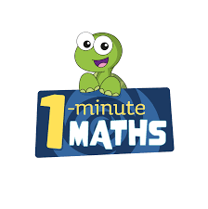

White Rose Maths have created an app called 1-Minute Maths. The app aims to help children build
greater number confidence and fluency through targeted practice in engaging, one-minute
chunks. Your child can choose any topic they want to try. They then answer a unique series of questions
(a different set of questions is generated each time). If they’re finding a question tricky, a ‘hint’
button will give a helpful clue by showing the question in a different way for example. When the

one minute is up, you will see a feedback screen detailing your child’s score. You can use this to move your child’s learning forward. The 1 Minute Maths app requires no login or internet access. It is free to download and available at:

