

Mathematics Home Learning
In Reception, children are introduced to the composition of 5 by exploring the different ways that the number 5 can be made. Children may begin by using everyday objects such as blocks or their fingers to show combinations like 3 and 2, 4 and 1, or 5 and 0. They learn that numbers can be broken apart and put back together again, and that there are many different number pairs that make 5. We use mathematical language such as altogether, part, whole, and questions such as how many more do we need to make 5? Please scan the QR code below to watch a home learning video on the topic of ‘composition of 5’ before completing the follow-up activity attached.


Home Learning Video

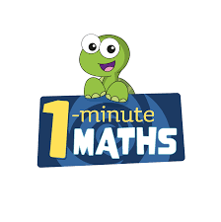

White Rose Maths have created an app called 1-Minute Maths. The app aims to help children build
greater number confidence and fluency through targeted practice in engaging, one-minute
chunks. Your child can choose any topic they want to try. They then answer a unique series of questions
(a different set of questions is generated each time). If they’re finding a question tricky, a ‘hint’
button will give a helpful clue by showing the question in a different way for example. When the

one minute is up, you will see a feedback screen detailing your child’s score. You can use this to move your child’s learning forward. The 1 Minute Maths app requires no login or internet access. It is free to download and available at:

