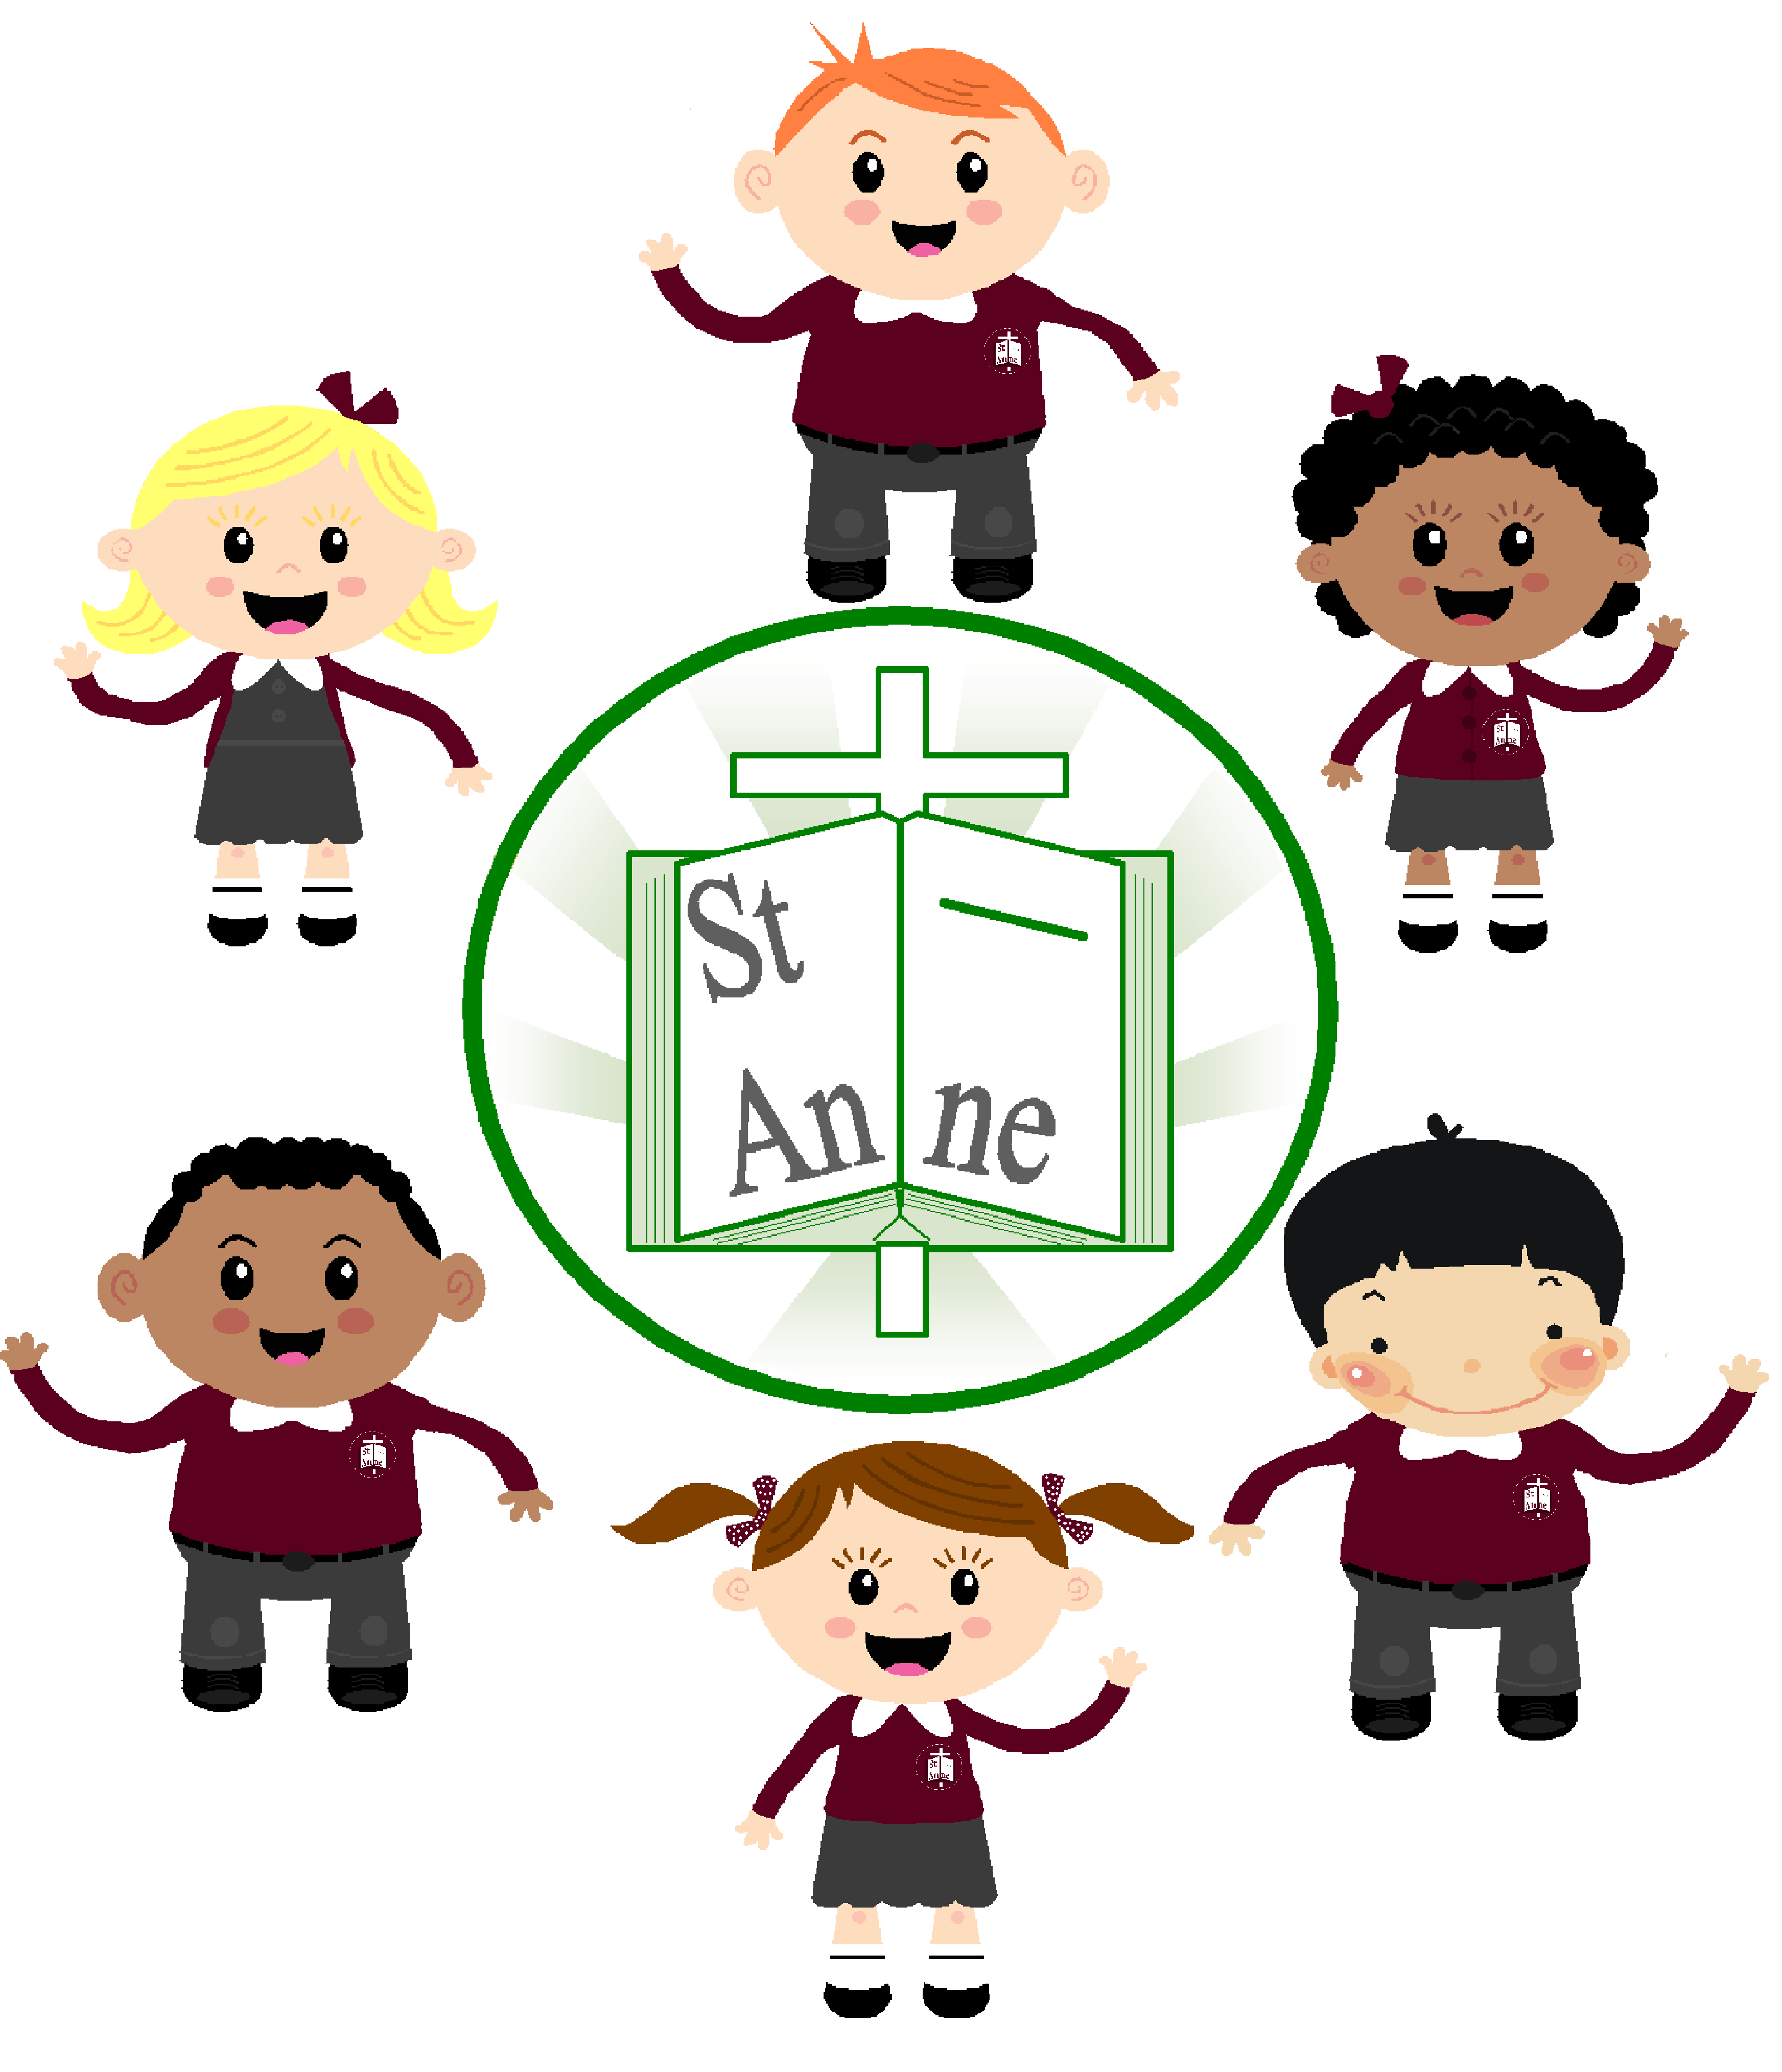

Friday 12th December 2025

Dear Parents and Guardians,

We have had a wonderful week celebrating Christmas with Reception’s Christmas lunch, Christmas party and Santa Dash. We have been enjoying lots of Christmas crafts, including writing Christmas cards for our families. Our outdoor post office will be opening next week, in time for the Christmas rush! The children will be writing cards and letters and pretending to post them to friends and family. Activities such as these support the children to appreciate the real-world relevance of writing. If you have any spare writing pads, notepads, post-it notes, envelopes, used stamps etc. please send them in for us to add to our post office. You can provide your child with purposeful writing opportunities at home by supporting them to write:

- Messages to family at home
- Cards to celebrate special occasions
- Shopping lists
- Menus for dinner
- Letters to faraway family or friends (even better if they could write back!)

Importantly, supporting your children to become writers involves the development of many skills including fine motor skills. The development of fine motor skills supports children with pencil grip and control. You can support the development of your child’s fine motor control through for example:

- Playing with Lego
- Threading beads
- Manipulating playdough, clay etc.
- Icing cakes
- Cutting and sticking activities

Thank you for your continued support.
Reception Staff

