

Mathematics Home Learning
We are learning to use 2D shapes, such as squares, oblongs/rectangles, circles and triangles to create a shape picture. The children are exploring how these shapes can be combined, arranged, and positioned to make simple images. They are learning to recognise the shapes by counting their sides and noticing their features, then using them purposefully in their artwork. You can support your child by exploring 2D shapes together at home, for example:
• finding 2D shaped objects around the house that could inspire their picture
• pointing out 2D shapes in books, packaging, or signs
• comparing shapes: “Which would make a window? Which could be a door?”
• working together to cut out, draw, or arrange 2D shapes to make your own shape picture.
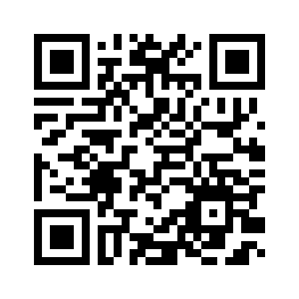
Please scan the QR code below to watch a home-learning video on creating shape pictures before completing the follow-up activity attached.
Home Learning Video

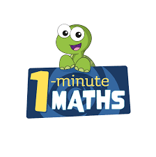

White Rose Maths have created an app called 1-Minute Maths. The app aims to help children build
greater number confidence and fluency through targeted practice in engaging, one-minute
chunks. Your child can choose any topic they want to try. They then answer a unique series of questions
(a different set of questions is generated each time). If they’re finding a question tricky, a ‘hint’
button will give a helpful clue by showing the question in a different way for example. When the

one minute is up, you will see a feedback screen detailing your child’s score. You can use this to move your child’s learning forward. The 1 Minute Maths app requires no login or internet access. It is free to download and available at:

