

Mathematics Home Learning
We are learning to name and identify 4-sided shapes, such as squares, rectangles/oblongs, and other quadrilaterals. The children are exploring how to recognise these shapes by counting sides and looking at their features. You can support your child by spotting 4-sided shapes in everyday situations, for example:
- finding square or oblong/rectangle objects around the house
- pointing out 4-sided shapes in books, packaging, or signs
- comparing shapes: “Which ones have 4 sides?”
- working together to draw or make your own 4-sided shapes
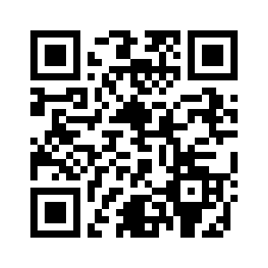
Please scan the QR code below to watch a home-learning video on naming and identifying 4-sided shapes before completing the follow-up activity attached.

Home Learning Video

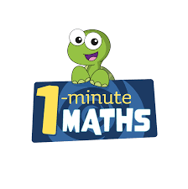

White Rose Maths have created an app called 1-Minute Maths. The app aims to help children build
greater number confidence and fluency through targeted practice in engaging, one-minute
chunks. Your child can choose any topic they want to try. They then answer a unique series of questions
(a different set of questions is generated each time). If they’re finding a question tricky, a ‘hint’
button will give a helpful clue by showing the question in a different way for example. When the

one minute is up, you will see a feedback screen detailing your child’s score. You can use this to move your child’s learning forward. The 1 Minute Maths app requires no login or internet access. It is free to download and available at:

