

Mathematics Home Learning
As part of our current maths topic, we are learning to find, understand, and represent one more and one less within 5. We are exploring how numbers change when we add one more or take one away. You can support your child by practising this in everyday situations e.g., one more carrot on the plate; one less toy in the basket; one more clap; one less block in the row. Please scan the QR code below to watch a home learning video on the topic of ‘one more and one less (within 5)’ before completing the follow-up activity attached.


Home Learning Video

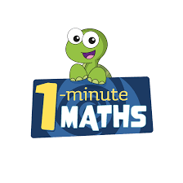

White Rose Maths have created an app called 1-Minute Maths. The app aims to help children build
greater number confidence and fluency through targeted practice in engaging, one-minute
chunks. Your child can choose any topic they want to try. They then answer a unique series of questions
(a different set of questions is generated each time). If they’re finding a question tricky, a ‘hint’
button will give a helpful clue by showing the question in a different way for example. When the

one minute is up, you will see a feedback screen detailing your child’s score. You can use this to move your child’s learning forward. The 1 Minute Maths app requires no login or internet access. It is free to download and available at:

