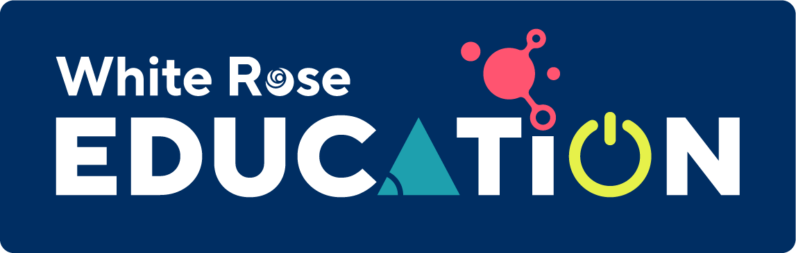

Mathematics Home Learning
In Reception, children are introduced to the topic of shape by first exploring circles and triangles and beginning to describe their properties. Children may use informal language such as ‘pointy’ or ‘sharp’ to describe what they notice. We introduce mathematical language for describing the properties of circles and triangles, such as ‘sides ’, ‘straight’, ‘corners ’ and ‘round’.Children learn that triangles are flat shapes with three straight sides and three corners, and that circles are flat shapes which are perfectly round. When using physical representations of 2-D shapes, ensure that you support children’s understanding that they are flat. Please scan the QR code below to watch a home learning video on the topic of ‘circles and triangles’ before completing the follow-up activity attached.
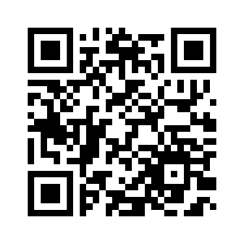
Home Learning Video

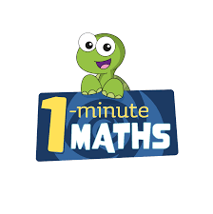

White Rose Maths have created an app called 1-Minute Maths. The app aims to help children build
greater number confidence and fluency through targeted practice in engaging, one-minute
chunks. Your child can choose any topic they want to try. They then answer a unique series of questions
(a different set of questions is generated each time). If they’re finding a question tricky, a ‘hint’
button will give a helpful clue by showing the question in a different way for example. When the

one minute is up, you will see a feedback screen detailing your child’s score. You can use this to move your child’s learning forward. The 1 Minute Maths app requires no login or internet access. It is free to download and available at:

