

Mathematics Home Learning

In Reception, children learn about one more and one less through hands-on counting, songs, and games using real objects. This builds early number sense, supporting children to recognise the relationship between numbers. You can support your child to develop their understanding of one more and one less through counting everyday objects before asking “What is one more/less”? You can then add one more object/take one away to show the answer. Please scan the QR code below to watch a home learning video on the topic of ‘one more/one less’ before completing the follow-up activity attached.

Home Learning Video

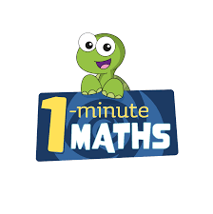

White Rose Maths have created an app called 1-Minute Maths. The app aims to help children build
greater number confidence and fluency through targeted practice in engaging, one-minute
chunks. Your child can choose any topic they want to try. They then answer a unique series of questions
(a different set of questions is generated each time). If they’re finding a question tricky, a ‘hint’
button will give a helpful clue by showing the question in a different way for example. When the

one minute is up, you will see a feedback screen detailing your child’s score. You can use this to move your child’s learning forward. The 1 Minute Maths app requires no login or internet access. It is free to download and available at:

