

Mathematics Home Learning
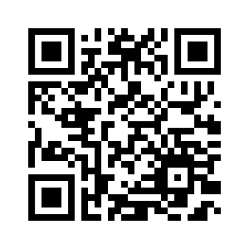
Reception children learn about sorting 1,2, and 3 with a view to building early number sense – understanding quantity, grouping, and comparison (more, fewer, same). You can support your child by sorting everyday objects (toys, socks, spoons) into groups of 1, 2, or 3 and talking about what they notice – “You’ve got two cars here; can you find three blocks?” – to make learning playful and practical. Please scan the QR code below to watch a home learning video on the topic of ‘sorting 1, 2, and 3; before completing the follow-up activity attached.

Home Learning Video
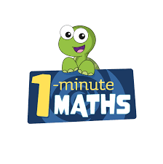

White Rose Maths have created an app called 1-Minute Maths. The app aims to help children build
greater number confidence and fluency through targeted practice in engaging, one-minute
chunks. Your child can choose any topic they want to try. They then answer a unique series of questions
(a different set of questions is generated each time). If they’re finding a question tricky, a ‘hint’
button will give a helpful clue by showing the question in a different way for example. When the

one minute is up, you will see a feedback screen detailing your child’s score. You can use this to move your child’s learning forward. The 1 Minute Maths app requires no login or internet access. It is free to download and available at:

