

Mathematics Home Learning
In Reception, children compare amounts using objects that they can see, touch, and move. You can support your child’s learning at home by encouraging your child to compare groups of toys, blocks, or counters for example (Which group has more? Which group has fewer?) and through sharing out snacks or teddies for example before checking if everyone has the same amount. Please scan the QR code below to watch a home learning video on the topic of comparing amounts before completing the follow-up activity attached.
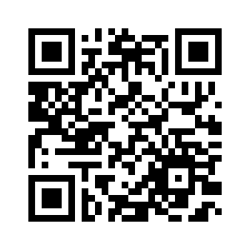

Home Learning Video

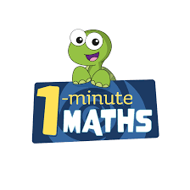

White Rose Maths have created an app called 1-Minute Maths. The app aims to help children build
greater number confidence and fluency through targeted practice in engaging, one-minute
chunks. Your child can choose any topic they want to try. They then answer a unique series of questions
(a different set of questions is generated each time). If they’re finding a question tricky, a ‘hint’
button will give a helpful clue by showing the question in a different way for example. When the

one minute is up, you will see a feedback screen detailing your child’s score. You can use this to move your child’s learning forward. The 1 Minute Maths app requires no login or internet access. It is free to download and available at:

