

Mathematics Home Learning

In Reception, children explore matching and sorting by grouping objects by colour, size, or shape. You can support your child’s learning at home by encouraging your child to notice the characteristics of, and sort, everyday objects. Please scan the QR code below to watch a home learning video on the topic of matching before completing the follow-up activity attached.

Home Learning Video
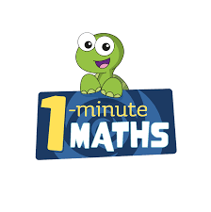

White Rose Maths have created an app called 1-Minute Maths. The app aims to help children build
greater number confidence and fluency through targeted practice in engaging, one-minute
chunks. Your child can choose any topic they want to try. They then answer a unique series of questions
(a different set of questions is generated each time). If they’re finding a question tricky, a ‘hint’
button will give a helpful clue by showing the question in a different way for example. When the

one minute is up, you will see a feedback screen detailing your child’s score. You can use this to move your child’s learning forward. The 1 Minute Maths app requires no login or internet access. It is free to download and available at:

