

Mathematics Home Learning

In Reception, children learn to describe position through play-based and practical activities that help them understand where things are in relation to themselves and others. Using everyday experiences such as placing toys “on”, “under”, or “next to” objects, following simple instructions, and engaging in stories or games with positional language, they begin to develop spatial awareness. Please scan the QR code below to watch a home learning video on the topic of ‘positional language’ before completing the follow-up activity attached.

Home Learning Video

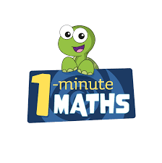

White Rose Maths have created an app called 1-Minute Maths. The app aims to help children build
greater number confidence and fluency through targeted practice in engaging, one-minute
chunks. Your child can choose any topic they want to try. They then answer a unique series of questions
(a different set of questions is generated each time). If they’re finding a question tricky, a ‘hint’
button will give a helpful clue by showing the question in a different way for example. When the

one minute is up, you will see a feedback screen detailing your child’s score. You can use this to move your child’s learning forward. The 1 Minute Maths app requires no login or internet access. It is free to download and available at:

